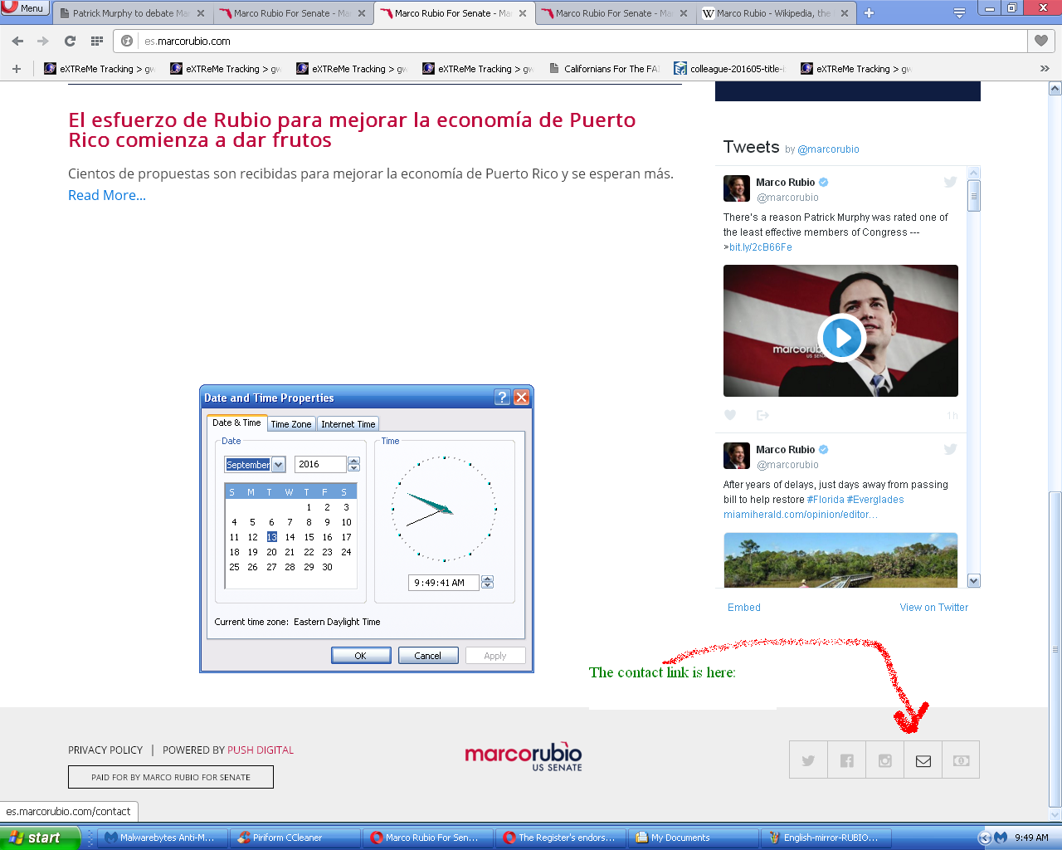

Close up view of es.MarcoRubio.com – the Spanish mirror:

(top of page)
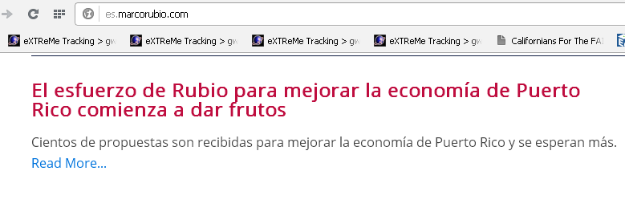

(bottom of page)


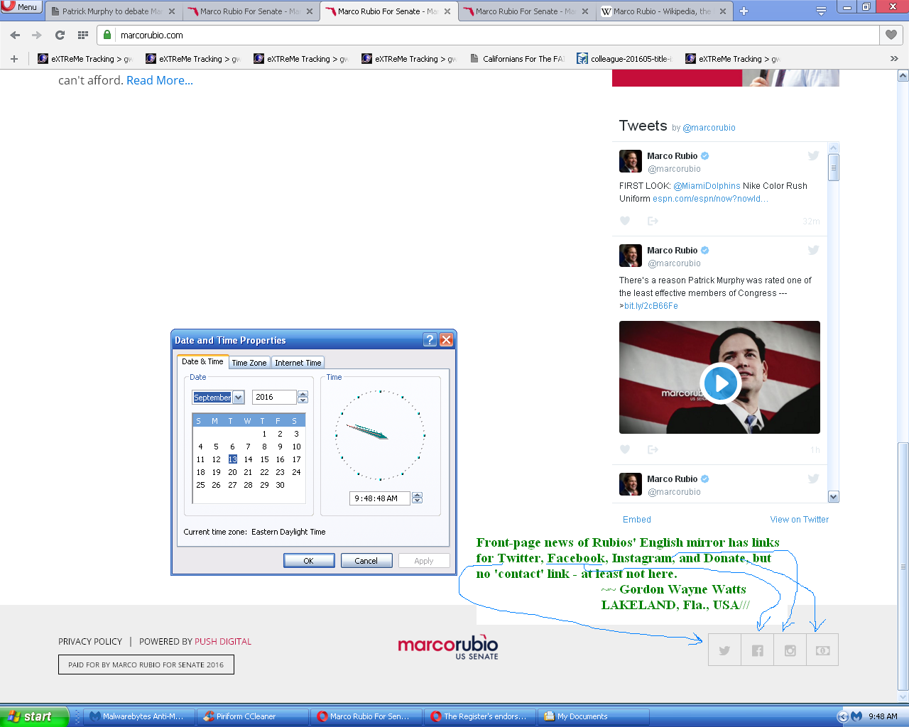

Close up view of MarcoRubio.com – the English mirror:

(top of page)
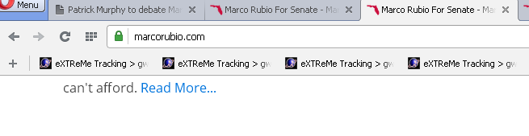

(bottom of page)

