PublicStatementOnDocumentedDreams_GordonWayneWatts_Fri03May2024_DOC.doc
PublicStatementOnDocumentedDreams_GordonWayneWatts_Fri03May2024_PDF.pdf
PublicStatementOnDocumentedDreams_GordonWayneWatts_Fri03May2024_HTML.html

PRESS RELEASE

SUBJECT: Public Statement regarding Documented Fulfillment of Dreams

FROM: Gordon Wayne Watts (Plant City, FL, USA), Editor-in-Chief, THE REGISTER
Nat'l Dir, CONTRACT WITH AMERICA: PART II®TM Registered Trademark

TO: General public press release
(“Blanket permission” is given to any/ all to share/ republish in its entirety – without alteration)

DATE: Friday, 03 May 2024

For some time, I've noticed many of my dreams be fulfilled with startling accuracy[APPENDIX-A], either literally or symbolically – something which made me wonder whether God Almighty is trying to speak to me – something accepted by many religions – including mine (Christian). However, last year, I had an exceptionally frightening dream about my friend, the late Ian Punnett, warning that his life was in grave danger – and I made a Herculean effort to warn him – and assure him I was praying for him{*1*} – and it's well-documented[APPENDIX-B] that this dream, and attempts to warn him, occurred BEFORE he passed away shortly afterward, very unexpectedly{*2*} and at a relatively young age{*3*}. [Notes: {*1*} In my religion, normally prayer is a private matter – MATTHEW 6:1-6, Jesus speaking, warning that bragging or public showboating is inappropriate when praying usually – but LUKE 22:32 gives a rare exception where Jesus showed it's occasionally OK to tell someone you prayed for them to offer needed encouragement or uplifting – when he told Peter that He'd prayed for him regarding upcoming challenges. {*2*} Ian's medical condition was NOT publicly known – and not known by me; he looked young and healthy on my end. {*3*} He was only 63 when he passed; a cursory look at “actuary tables” verifies it's VERY rare for someone at that age to suddenly pass away, as he did. Making me wonder how/ why I had such an accurate predictive/ prophetic dream.]
I'm not taking this well – not only because Ian was my friend, but also because I don't know if he received my message in time either to take precautions, that might have bought him a little more time and/or to uplift/ encourage him that his friend was praying for him – and because I feel VERY bad I didn't try harder to confirm/ ensure he got my message in a timely fashion. Since this loss was great – and well-documented[APPENDIX-B] to have been an accurate warning of the future – this was a “wake up call” for me, reminding me I've had plenty of other dreams[APPENDIX-C] that should be documented publicly, in case they come true too. My religion says we're supposed to “test the spirits,”[APPENDIX-D], so here's a summary of dreams I've had that I feel we should keep any eye on – and further thoughts/ analysis:

SUMMARY: These dreams depict several surprising things, including Trump picking Rand Paul as VP running mate, Chinese economic warfare by dumping lots of US Dollars on the market, and GOP lawmakers turning over a new leaf regarding key legislation – cutting certain “liberal” pork spending – and obeying the U.S. Constitution's requirements for bankruptcy uniformity as it applies to collegiate debt – The UNIFORMITY CLAUSE – Art. I, Sec. 8., cl.4, is a special case of EQUAL PROTECTION – and not even in the AMENDMENTS – but the actual original articles of the U.S. Constitution. CAVEAT: I have no earthly idea if these dreams are from God (am seeking to “test the spirits”), but the dreams did happen – and, as clarified and well-documented above – many of my prior dreams have been shockingly accurate – even when there was no way I could have known in advance what many of them VERY accurately predicted.

Index of Appendices:
- APPENDIX-A: prior dreams fulfilled with startling accuracy
- APPENDIX-B: my dream about Ian; documented proof dream occurred before fulfillment
- APPENDIX-C: other dreams I've had that I feel we should keep any eye on
- APPENDIX-D: info on whether we should test the spirits (and how to do so)
- APPENDIX-E: Frequently Asked Questions (FAQs)

** APPENDIX-A: prior dreams fulfilled with startling accuracy **

- Sunday, 4-12-2015 – DREAM – I visit a certain unnamed high school classmate up town, and ask mom & dad if they can take us out to lunch. FULFILLMENT – A few hours after my dream (shortly after midnight, eg, Monday, 4-13-2015, I stop & get gas at the convenient store on NW corner of Thonotosassa Rd & I-4, and a mutual friend asks about him, and that's the first time in years I'd heard from him. (Years earlier, I had dreamed I was visiting his rental cubicle up town, and a few hours later, he emailed me out of the blue, letting me know he found THE REGISTER (my blog) online, and I hadn't heard from him in years before that.) COMMENTS: These 2 dreams weren't literal, but the timing was very unlikely, and it qualifies as a “symbolic” dream, like those in The Bible – both times, I had a dream and then heard about him – or from him. Though not in my Dream Journal going back to Thursday, 11-7-2013, nonetheless, I pulled from email notes to another classmate that on Saturday, 10-11-2008, I dreamed mom & I visited his old cubicle rental in a small shopping center near Collins and Baker and Reynolds streets (Plant City, FL), where he had a newspaper business, and then hours later the next day, Sunday, 10-12-2008 (shortly after midnight according to my notes), he emailed me even tho I hadn't heard from him in about 14-15 years prior after he moved away from Florida. Wow.
- Tuesday, 6-9-2015 – DREAM – Dad had to call a tow truck. FULFILLMENT – The next day, Wednesday, 6-10-2015, I had to call AAA towing when I had a dead battery after church. COMMENTS: Again, not literal (dad wasn't in my dream), but “symbolic,” and – I add – more literal than most/all Bible dreams: My dream and the fulfillment both involved tow trucks (literally correct on that, even if a different person was driving the stranded car) – but, by contrast, King Pharaoh's dream (skinny cows eating fat cows, Genesis 41:25-36) was NOT literal: The 7 skinny cows were symbolic and represented 7 years of famine. And, King Nebuchadnezzar's dream (a statue, Daniel, chapter 1—2) was NOT literal: The statue's various body parts represented various kingdoms. And, Peter's dream/vision regarding unclean food (Acts 10:9-18) was NOT literal: The unclean food represented gentiles (Acts 11:4-17), whom Jewish believers considered “unclean” until Peter's word from God to the contrary. So, my dreams – while usually symbolic – are often more literal than most/all Bible dreams/visions.
- Wednesday, 4-11-2018 (PM) – DREAM – Dad's in a wheelchair with an IV and watching a T.V. Football game. FULFILLMENT – My father, Robert Franklin Delano Watts, passed away on Thursday, 5-3-2018, less than a month later. COMMENTS: Symbolically true – in dream he was very sick.
- Tuesday, 8-7-2018 (AM) – DREAM – I call in to COAST TO COAST: AM & later visit host, George Noory & call-screener, Tommy Danheiser. In my dream, George is about my height & Tommy, about 3” taller. FULFILLMENT – I went online to see how tall they were, and my dream was accurate on that count (tho I didn't previously know), as I'm about 5'9” with shoes, George 5'9” and Tom, 6'0”. How'd my dream “know” how tall they are!?.. Hmm... ?.. However, I haven't ever met them in person as yet.
- Tuesday, 11-5-2019 (AM) – DREAM – Woman parachutes over mailboxes near my home & is killed when main chute fails. FULFILLMENT – A few days later, news reports dated 11-6-18 and 11-7-17 started coming in that a BOEING CST-100 Starliner “space taxi” crew capsule – on a (luckily) unmanned “test flight” – failed due to loss/failure of a pin, forcing a hard landing, using two (2) – not the planned three (3) – chutes. My dream was in AM, eg, the morning the day before 1ST news report.
- Thursday, 5-21-2020 (AM) – DREAM – A Facebook acquaintance comes to my front door along with others who are there to meet up for a singles event, but she was only there to pick up a notebook she left, not to go on a singles outing with the rest of us. FULFILLMENT – The following day, I took a look at her Instagram, on a hunch & found a post she'd made about 8PM (after my dream), in which she'd talked about going to “singles” events – similar to my dream. (Odd as she didn't often talk about dating, nor do I recall dreams about her in this regard, other than this one.) I messaged her about it, asking what she thought. She was polite, but firm, that she wasn't interested in me romantically. NOTE: Two ways to look at this symbolic (not literal) dream: First, it might seem false, as she wasn't interested in me. However, closer inspection reveals that the dream depicted her as coming to the house during the meetup schedule, but for purposes NOT related to dating. ANALYSIS: True (albeit symbolic) dream. Moreover, when we were discussing this, she emphatically insisted I not discuss dating and that this was a “boundary” I must abide by if I wanted to talk to her, and she was seemingly over this misunderstanding or offense. However, later, when I saw an INSTAGRAM story about her having been sexually assaulted, and made a brief, positive, comment expressing my condolences, and a reminder that I would grant her request to respect her boundaries (and not make a pass at her or discuss dating etc), she immediately blocked me on both INSTAGRAM and FACEBOOK – suggesting she was under stress, mentally unstable, and/or not compatible with me – further evidence my dream was accurate, even if it took a few tries to understand it meant she **wasn't** a good romantic match.
- Thursday, 1-7-2021 (PM) – DREAM – I see 2 planes fly REAL low while visiting a neighbour & good friend. FULFILLMENT – News reports came out 2 days later, Saturday, 1-9-2021 that SRIWIJAYA AIR Boeing 737-500 air Flight 182, with sixty-two (62) passengers, lost contact after departure from Jakarta, Indonesia, at 2:40 P.M., WIT (Western Indonesia Time), aka 2:40 A.M., EST (Eastern Standard Time), and subsequently discovered crashed via wreckage found. News reports say faulty throttle system and/or delayed pilot response (operator error) to blame. ANALYSIS: While clearly not literal, this seems clearly symbolically true insofar as both dream and real life depict a VERY RARE airplane mishap. I.e., I VERY rarely dream of airplane tragedy, and VERY rarely does it happen. Coincidence?.. I think not. Clearly, God is showing me something. Just not sure what. NOTE: Even if I'm confused at first, this still may be a valid, genuine dream from God – remember, both Nebuchadnezzar, Pharaoh, and even the prophet Samuel – see I SAMUEL chapter 3 – all three didn't know it was God speaking to them at first. But it still was from God – and the problem was with them (not God), who sent valid dreams/ visions.
- Sunday, 8-29-2001 (AM) – DREAM – I see a “Shawn” and “Melissa” (first names only to protect anonymity, but mentioned to jog my memory if asked about it) up town. FULFILLMENT – Mere hours after this, Shawn's girlfriend, who is from Ghana, Africa, messages me after over a year of not hearing from her, asking if I've heard from Shawn. ANALYSIS: The timing of this freaks me out. ADDITIONALLY: About a week or so ago, an unnamed cousin of Shawn asked me if I'd heard from him, and just days later, that same friend from Africa (who had no idea his cousin asked about him) also asked about him. Both cases were very unlikely coincidences. VERY unlikely. In both cases, Shawn's Ghanaian girlfriend asked about him right after either a dream or another friend asking about him, so I'm not sure if she's got some gift from God – or if it's my dream – but these coincidences are statistically super unlikely. Hmm..?..
- Thursday, 10-21-2021 (Late AM) – DREAM – I'm inside a house with a very good friend of mine, and we watch 2 telephone/ power line poles violently spark/ arc with electricity for several minutes while only about 5—10 feet apart. Very scary dream!! FULFILLMENT – Just a few hours later, I message her that I find it very undesirable that she's going through some unattractive emotional pain or weakness, and she mistakenly thinks I meant that SHE'S undesirable or unattractive, and blocks me on Facebook –i.e., sparks flew emotionally in ACCURATE fulfillment of my dream.
- Thursday, 10-21-2021 (Late AM) – DREAM – That same morning, I had another dream about the same friend, above: She, I, and a school friend of mine – all 3 of us – were working on a construction job site. We walk upstairs & she gets on the ground with tools to work on something. FULFILLMENT – That dream was in 2021, and yet just recently (June 28, 2023, to be exact), she made passing comments about getting back into construction, as the pay was good. I had not idea she used to work in construction, and yet I dreamed it! ..Wow.?.. (Again, not literally true – as yet – but freaks me out I'd have a dream with such starkly accurate details as to her vocation, occupation, & work history!!)
- Friday, 10-29-2021 – DREAM – This same friend (above) unblocks me on Facebook. FULFILLMENT – A few months later, after emotions cooled, I messaged her on her alternate account and apologised. She displayed great honour & genuine friendship and unblocked me. ASSESSMEMT: Dream is TRUE.
- Wednesday, 1-19-2022 – DREAM – I find nitrous oxide fuel additive & old french fries in the cabinet above my kitchen sink. FULFILLMENT – A few days later (Sun.1-23-22), on a hunch, I looked in that cabinet and found some much-needed honey. ANALYSIS: While not literally true, the honey – like the fuel additive & fries – was a form of energy. Considering I didn't know the honey was there beforehand, I assess this as a symbolically true dream – like many of Bible days.
- Sunday, 7-17-2022 (AM) – DREAM – This dream is very similar to my Tue. 8-7-2018 dream: I stand in an on-stage lineup, between George Noory (to my left) & Tom Danheiser (to my right), and – like the prior dream – George is about my height (5'9” with shoes), and Tom is about 3” taller – both true facts I didn't know prior to my 2018 dream. ASSESSMENT: Here, I probably remember I'd Googled their height back in 2018, so this dream stands alone in how it's not miraculous: My memory probably played a part. However, practically all other dreams, in APPENDIX-A, here, can only be explained by the supernatural. NOTE: George & Tom are host & call-screener, respectively, for the legendary COAST TO COAST: AM show – the largest international call-in show in the world – and airing live, even on holidays – which, ironically, is about paranormal matters, among other things – and is legendary for being the show about UFO's, paranormal, Bigfoot – and, more recently, science, health, conspiracy theories, and current news and science – and protecting our fragile power & telecommunications grid.
- Monday, 2-27-2023 (PM) – DREAM – In this dream, the U.S. SUPREME COURT rules that Pres. Biden can't keep/ continue doing “PAUSES” on Student Loan Repayment, Interest, & Fees by Executive Order if he loses his “Forgiveness” aka “Cancellation” by EXECUTIVE ORDER case they had before them – i.e., limits on “Executive Order” powers. ANALYSIS: Astute historians will vividly remember that the bipartisan “Debt Ceiling” bill – which was passed into law shortly after this – did exactly that, e.g., limited Pres. Biden's authority to keep doing an Executive Order to continue to extend the “repayment pause.” ASSESSMENT: I'm glad that – contemporary to this dream, I didn't ever say “Thus Saith The Lord” that this would happen. While some friends may remember me talking about it, I was careful to not make myself into a false prophet (this dream literally DIDN'T come true, since the Exec Order limits were places by LEGISLATIVE action, not JUDICIAL – both good examples of a Separation of Powers in our 3-part form of Government. That said, a good case can be made that this dream was symbolically true – and thus probably from God. Moreover, any limits placed here by lawmakers or the courts totally caught me off guard, as I didn't think Republicans wanted to tick off, anger, & alienate voters on this popular EXECUTIVE ORDER initiative, given how costs of college are so unaffordable nowadays. So, while I don't see “cancellation” as any long-term solution to protect either taxpayers (a concern of Conservatives like me) or students (a valid concern of Liberals), I expected Biden to be permitted – and thus the ACCURATE “Symbolic” fulfillment of this dream seems to be divine in origin – I was not expecting the GOP to wake a sleeping giant like this.
- Friday, 3-3-2023 (Late PM) – DREAM – I chat with Pres. Biden (hoping to seek his support on key legislation discussed elsewhere on my blogs), and he tells me to get an interview with the newspaper. Then, in the dream, he slips and falls – injuring himself. I tell him I'm praying for in (in the dream) – and wake up immediately, and pray for him, in real life. This was very frightening, as I'm not happy to see ANYONE in pain or suffering. FULFILLMENT – News reports dated 3/6/2023 and 3/7/2023 say that Pres. Biden did, indeed, stumble, and almost fall, while boarding AIR FORCE ONE on a trip returning from Selma, AL back to Delaware, after an apparent campaign stop to commemorate the 58TH anniversary of the “Bloody Sunday” civil rights march and push Congress for election reform legislation. ANALYSIS: It is true that about 2 weeks prior, Biden had a similar stumble in his European trip to or from Kyiv, UKRAINE, so a good case can be made for my subconscious mind “seeing something,” and – thankfully – he wasn't hurt badly in real life (like in my dream), but I almost NEVER dream about Pres. Biden falling, and he almost never does (pretty rare, thankfully), so this dream is yet another odd coincidence – and symbolically true. Like so many Bible dreams back in the day. (Note: When things like this happen, pray – and, if possible, try to warn the person in question to be careful – like you'd want if the roles were reversed.)
- Tuesday, 5/2/2023 (Late PM) – DREAM – A certain Facebook friend – a young girl who was 18 at the time – asks me to meet her in real life (in person) at a lakeside public park and meet her father, who solicits my help putting together a family reunion, as I know many of their family. FULFILLMENT – A few weeks later, or so, I vividly recall her video chatting with me and asking if I'd meet her and her then-boyfriend up town, in person. NOTE: One friend suggested my “subconscious” saw she was talkative and figured she'd ask me to meet in person later on, but I'm calling BULL on that analysis: I have close to FOUR (4,000) THOUSAND Facebook friends at the time of this writing, and can't remember ANY of them asking to meet me in person – and I have never had a dream of this type. While the details were slightly “off” as to literal fulfillment, still, this dream is more literally true than most/all dreams we find in the Bible – and thus more of a case can be made that it's really from God. Note: This same friend, when telling her about my dream, conveyed to me that she had 2 true predictive dreams: one of visiting a certain place at Universal/Disney in Orlando and another of a “bad” boyfriend breaking up with her; she reports that both dreams subsequently came true, as she'd dreamed them. Odd.?.. But I believe her.
- Friday, 5/12/2023 (AM) – DREAM – An unnamed friend from Helping Hands Ministry comes back the next day to finish painting out house (had to pressure wash it first) but doesn't bring his helper with him, and reports he got fired, thus delaying work somewhat. FULFILLMENT – That morning, after awaking from this dream, I carefully wrote it down (just to be on the safe side), but didn't think it had any merit. And I texted (or called?) the HILLSBOROUGH COUNTY CODE ENFORCEMENT employee who had set up the meeting, asking when the paint crew would be back out (I wanted to sleep in until the last minute before going out to help them and keep any eye on things). Surprisingly, he informed me that they would have to postpone til next week, but didn't know why. However, the following Monday, 5/15/2023, the painter came back out, and I asked him what had happened. He said his helper quit, forcing them to postpone – VERY SIMILAR to my dream. Note: A friend of mine said that when I saw the helper get mad because his boss wouldn't let him have a Red Bull energy drink I offered them (which I admit was odd), my subconscious “knew” the guy would quit or get fired. I don't believe it, but – to be fair – I mention his theory. The boss said he was OK with the helper having a Red Bull, but that HIS bosses laid down the rule, and the helper said the business owners WERE ok with it, thus there was a bit of job site disagreement, here. My guess is that the owner of the volunteer ministry had former drug users doing “Community Service” time, and were afraid a Red Bull would be too much for them – but that is only a guess. This dream was very accurate (more accurate than most/all Bible-era dreams) – and, thus, from God.
- Friday, 7/14/2023 (PM) – DREAM – One friend tells me that puberty is difficult for her. FULFILLMENT – Shortly after this dream, she posted a “status” on Instagram (or maybe Facebook I rightly forget) that she was on her monthly menstrual period. This was quite similar to what I dreamed about her – and another symbolically true dream. (Although women occasionally post that they're on their period, still, I practically never have such dreams, and thus the timing is ...very, very odd.)
- Sunday, 7/16/2023 (AM) – DREAM – A certain, unnamed friend stands outside, in my front yard, insisting I come back home & help mom with something. In the dream, I'm next door at the house south of me, where a bus driver lives & I visit under dark hurricane weather. I yell back to my friend – across the yard & from next door – that she should NOT worry about staying to help mom, but rather she should go home now, lest she stay too long & end up “driving tired” after too many hours awake. FULFILLMENT – After I shared this dream with my friend, she shared with me that – at that exact time I was dreaming this – she was on the road, returning from an unannounced trip to Maryland to confront her then-boyfriend – since she still had a little bit of vacation time left from her work. What happened (in real life) was that her boyfriend's sister, who was living there, got jealous, and had a problem with my friend staying overnight, and – as a result – my friend & 1 of her 2 daughters who was along for the ride – had to sleep in the car for a few hours that night, and the next morning, she left Maryland for a 15-hour road trip with little sleep, and was seeing bunny rabbit hallucinations, and barely made it back alive! ASSESSMENT: Of course, the location of my dream vs 'real life' was not literally true, but the attempt to drive while sleep-deprived, was LITERALLY TRUE and happened at the SAME EXACT time as my dream. She never drives sleep-deprived in real life, and I never have such dreams. No explanation exists here except for Divine origin from God Almighty – Who I'm guessing wanted me to pray for her, and assure her afterwards I was praying for her – and let others know He can still send dreams/ visions/ angels, as needed. NOTE: While this dream was 100% accurately fulfilled – in real time – literally (as to what she did) – and symbolically (on some points, as to location) – nonetheless, in my religion, there is the belief that “Duel Fulfillment” sometimes occurs, and I feel that there is a good chance that this dream may be 100% LITERALLY fulfilled a 2ND time – “duel fulfillment” – and here is why: First, duel fulfillment is not without precedent. Secondly, my mother is quite old, and it is not untenable to expect my friend – whom is also mom's good friend – would want to care for her in a health crisis – but my life, with its twists & turns, may call me away to pursue other pursuits (financial, romantic, spiritual, etc.). And, should this occur when mom needs me, I may be faced with a crisis & crossroads of choices/ options: This dream, therefore, may LITERALLY come true where our friend yells at me to come back home and take care of mom, refusing to leave til I do – irrespective of the jeopardy into the which SHE would place herself when she has a home and a job in Lakeland, FL – about 10 or 15 miles distant from Plant City, FL – where mom & I live. I.e., my friend may end up driving to work “tired / fatigue” due to multitasking – as depicted in my dream, here. Time will tell...
- Monday, 7/24/2023 (PM) – DREAM – Two cops come into my front yard, one a Facebook friend who is a former cop and, the other, an Black cop I don't know and who cracks a joke that he's 92 years old. ASSESSMENT: I awake from this dream and look at my security system and see cops at my neighbor's house – something I didn't know when I was sleeping, as they hadn't made any noise. ..How odd.?.. again, symbolically true, and VERY unlikely coincidence, as I practically never dream about cops, and they don't often come out to where I live. Hmm..
- Thursday, 11/23/2023 (PM) – THANKSGIVING 2023 – DREAM – A very brief dream the evening of Thanksgiving 2023 depicts a certain (unnamed) neighbour who asked me to pray for him. FULFILLMENT – After I woke up that evening (Thanksgiving Day was VERY cold for me here in Plant City, FL), he called or texted me, inviting me over for Thanksgiving Dinner his family had fixed for me; I went over & hung out in his front yard (very cold for me). While eating, he made causal comments that he'd asked his workplace Chaplin (his company's owner is a Christian; it's a “faith based” business) to pray for a friend who'd just had heart surgery. This freaked me out because my neighbour was not only a self-proclaimed atheist, but (moreover) he'd repeatedly asked me to NOT discuss “God” or “religion” with him – so, while my dream was different than what happened (in a literal sense), still, I feel it was 100% ACCURATE insofar as it showed me he'd changed his views & now held a positive view of “prayer” and “God.” CLARIFICATION: Later on, he needed a ride to visit his friend (when his car wasn't working due to coolant system problems that limited travel to short distances). On the way over, I reminded him to inform his friend that he'd prayed for him. (I was under the belief that he was still atheist – e.g., a nonbeliever in God – and only asked the Chaplin to pray for his friend so he could report back an encouraging word: “I prayed for you, Buddy.”) However, my neighbour said that prayer was supposed to be private (as Jesus taught in MATTHEW 6:1-6), and I was taken aback. I asked for clarification, here: While he knew MYSELF, I believed this – nonetheless – I knew HE'D reported he didn't believe any of this religious bull/ nonsense/ etc – and asked for clarification: If YOU don't believe in prayer or God, then what benefit would it do for YOU to keep your prayers private? His response: He said that he'd been thinking about this & seemed to feel that sometimes there IS someone on the other end of the prayer, responding/ helping out. I freaked out – I had no idea he'd changed his views – but my dream – while symbolic (like most/ all Bible dreams) – nonetheless revealed this change of heard to me. Wow.!.. How could I have known?

Index of Appendices:
- APPENDIX-A: prior dreams fulfilled with startling accuracy
- APPENDIX-B: my dream about Ian; documented proof dream occurred before fulfillment
- APPENDIX-C: other dreams I've had that I feel we should keep any eye on
- APPENDIX-D: info on whether we should test the spirits (and how to do so)
- APPENDIX-E: Frequently Asked Questions (FAQs)

** APPENDIX-B: my dream about Ian; documented proof dream occurred before fulfillment **

- Saturday, 4/29/2023 (Late PM) – DREAM – I'm at an outside beach party and see my friend, Ian Punnett, who is a weekend guest host for COAST TO COAST: AM, the largest overnight call-in talk show worldwide. We chat briefly. As we talk, I see him start to stumble, lose footing, and fall. (In the dream, he looked like he'd had a bit too much to drink, but I wasn't sure – and knew only that he looked dizzy or disoriented/ fatigue.) As he falls, I lunge to catch him, but am a too slow, and he falls, hitting his head on the ground, very hard. I freak out, cradle him in my arms, and cry for 911 to be called – and cry out to God to help my friend, Ian – and wake up in a cold sweat, very shaken. FULFILLMENT – Ian Punnett, (b.3-3-1960 – d.12-22-2023) passed away at the young age of 63 from a genetic – and non-alcohol-related – liver condition. Friends often asked me if he passed away from slipping and falling (as depicted in my dream), I have reported back that the family has kept the details if his passing secret – and that I don't know. ASSESSMEMT: In trying to assess whether my dream was – indeed – a warning from God, trying to either help Ian in some material way and/or let him know that his friend, Gordon, was praying for him and/or to simply show proof that God is still alive and can do supernatural things, like dreams, we first ask: “Was my dream a correct prophecy/ prediction?” ANSWER: Since the family has chosen to not release details of his passing (and we must respect their privacy – if we are genuine Christians, ok?) – then we can safely say only this: Either he did slip & fall – or he didn't – that much is logically true. FIRST – I Googled his illness and note that 2 or 3 of the symptoms of his liver conditions are dizziness, fatigue, and possibly disorientation in some cases – thus it is possible that my dream was “literally” true as to detail. ALSO – It is equally possible that his passing was strictly from liver failure (he did not receive a liver transplant in time), and in this case, my dream – while not literally true – was indeed symbolically true (like most/ all Bible dreams that had strong Symbolic messages, clearly understood by the recipient): I saw death coming, tired to warn him, and it came to pass and did, indeed, happen.
- DOCUMENTED PROOF DREAM OCCURRED BEFORE FULFILLMENT: Before proceeding further, it is appropriate to provide readers with well-documented proof that I'm not just “making stuff up.” (Furthermore, it would be disrespectful to his family/ friends to “skip past” this matter of “proof.”)
- Additional requisite assessment: One friend (who is not a Christian, but is a very moral and caring friend, who is agnostic and uncertain about God/ religion) said I should NOT inform his wife, Marjorie Punnett – or any of his immediate family – of my dream, as it would accomplish nothing useful, and actually “bring back bad memories.” However, given the gravity of the situation (the dream does appear to be from god himself), I sought counsel from 3 others: FIRST, I asked a fellow-Christian who is also a regular listener to coast (and who knows Ian), and he felt I should let his wife know both my dream and that I had been praying for him. SECONDLY, I asked a middle-aged woman – also a fellow-Christian, and also a regular listener to COAST – her counsel. She agrees with my 1ST friend, but cautions me to both be respectful and not too lengthy as to details should I email Mrs. Punnett – counsel with which I agree. THIRDLY, I prayed about this, and asked God Almighty for help here: JUDAISM: Leviticus 19:18b, Leviticus 19:34, The Golden Rule, OLD TESTAMENT (PENTATEUCH) ; CHRISTIANITY: Matthew 22:39b, Mark 12:31b, Luke 6:31, Matthew 7:12, The Golden Rule, NEW TESTAMENT (HOLY BIBLE) – I feel The Lord asking me to remember the golden rule – and treat others as I'd want to be treated. For reasons described below, if the roles were reversed (and they were when I lost my father), I'D want to know the details of any dreams –and any documented proof of their veracity.

As promised, here's documented proof – both that my dream and my attempted warning occurred before Ian passed away – and that I made a Herculean effort to warn him to be careful (based on what my dream showed me) – and to assure him his friend, Gordon, was praying for him & his family:

- Private Instagram message, 3:07 AM, Monday, May 1, 2023
- Private Email, Cc copying George, Tommy, etc., 3:22 AM, Monday, May 1, 2023
- Private Facebook message, 3:25 AM, Monday, May 1, 2023
- (All 3 of which included a photo of selected portions of my Dream/ Prayer Journal)
- Public Facebook wall post comment, giving Ian a heads-up that I'd emailed him about a very scary dream (but not going into much detail, as it was public) Dated “47w” before Saturday, March 30, 2024:
If “52w” before was on Thursday, March 30, 2023,
then 47 weeks before would be approximately Thursday, May 4, 2023, ie, shortly after my email & messages. [DESKTOP SCREENSHOT]
- Link to that tread: https://www.Facebook.com/ian.punnett.1/posts/6139450832759144:648120600487568
- Archived PDF prints: https://ContractWithAmerica2.com/FannyDeregulation/IanPunnett_FacebookTHREAD_PDF.pdf
- Or: https://Web.Archive.org/web/20240330213814/https://ContractWithAmerica2.com/FannyDeregulation/IanPunnett_FacebookTHREAD_PDF.pdf
- Or “33w” before Screenshot_20231224-204323_Gallery, that is, about 33 weeks before Sunday, 12-24-2023 [SMARTPHONE SCREENSHOT], which would put my comment at around Sunday, May 7, 2023
- Call in to Open Lines when he was hosting and Gina was taking calls (sometime afterwards, I don't rightly recall) – but he was only taking new callers that night. I asked Gina if – during the commercial break – she could let Ian know I'd had a very scary dream about him, and to see if he could check his messages – take proper precautions – and to let him know I was praying for him. I can't remember my exact conversation, as Gina was pressed for time, but she said she'd try to let Ian know. I don't know if she was able to – or not – but I'm sure she tried.
- Ian and I had a minor misunderstanding – he blocked me on Twitter (his main “go to” for communication) – when he thought I had been too “talkative” – which was partly true – because another user kept provoking me, and I responded “one time too many.” I can't find that thread from a Google search (maybe he deleted it?) – and – thankfully – he wasn't mad at me: Ian was a true Christian, and continued to take my calls when, occasionally, I called in to COAST – but because I was blocked on Twitter, I was unable to have a secure means of warning him about my dream via Twitter.

Thus I made a Herculean effort to warn him to be careful when walking (based on what I saw in my dream) – as well as let him know I was praying for him.

Because I didn't know the precise nature of his illness, I was unable to help any further (and, in all fairness, his illness was very serious, probably fatal – as I understand it) – and he was very smart. But if I'd had a chance, I would have hoped to suggest liver cleansing herbs, a cleansing fast, Milk Thistle, or other things I learned during my time at college – and beyond.

Below are screenshots to verify the time-stamp claims of the above.

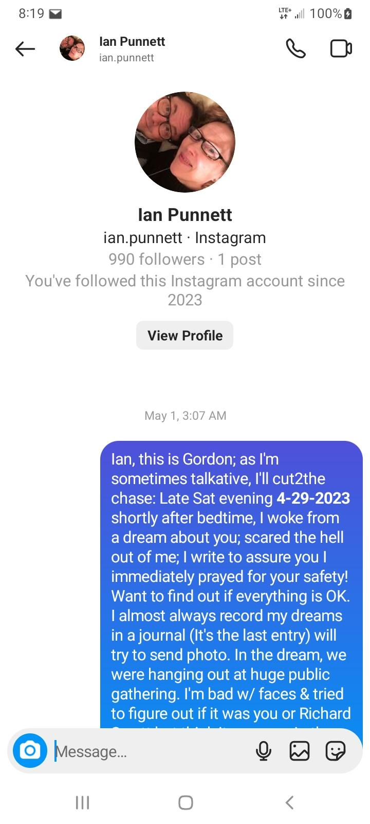
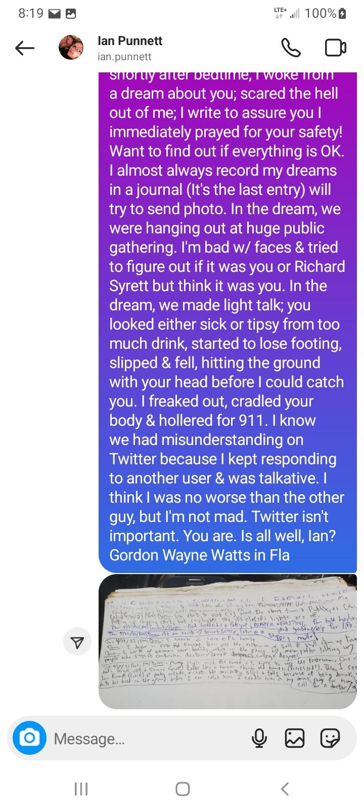

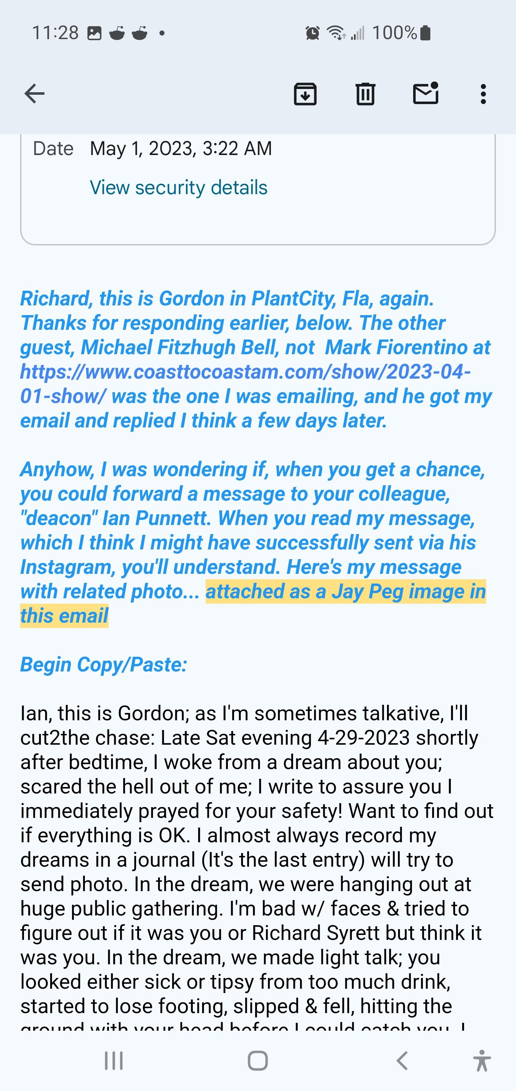

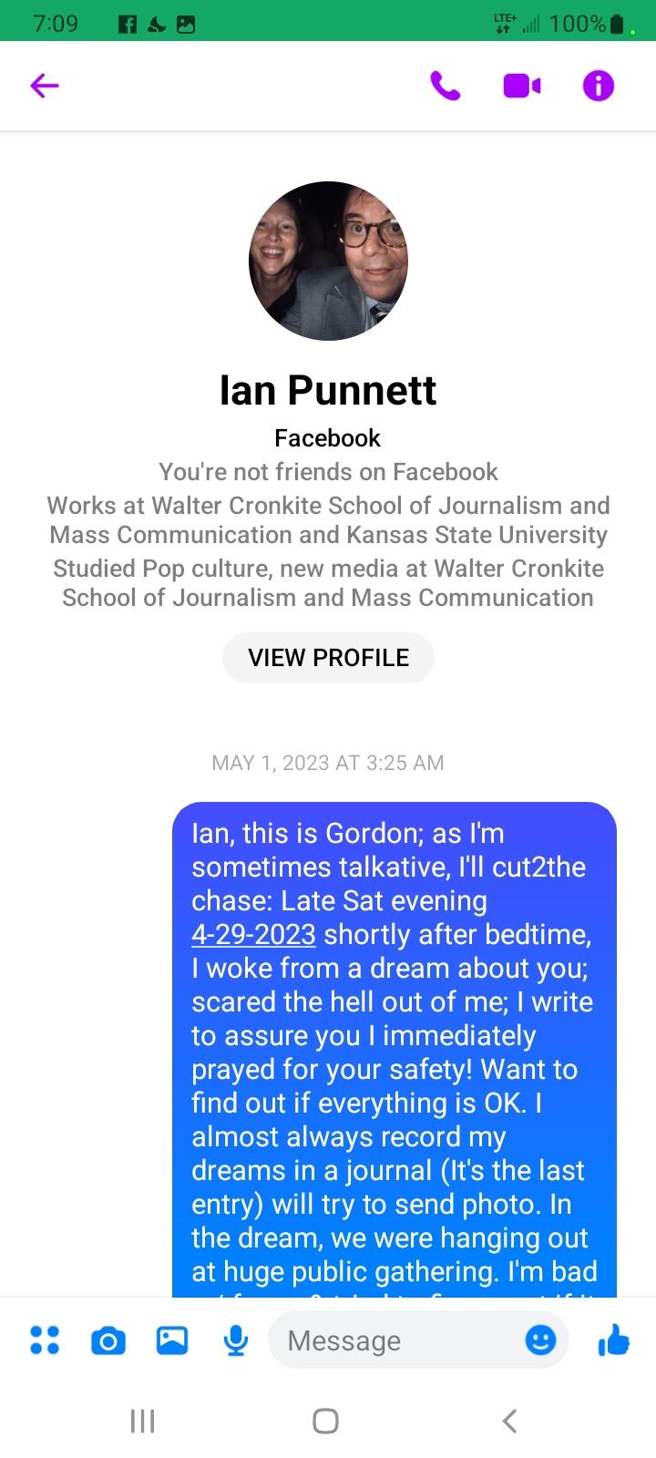
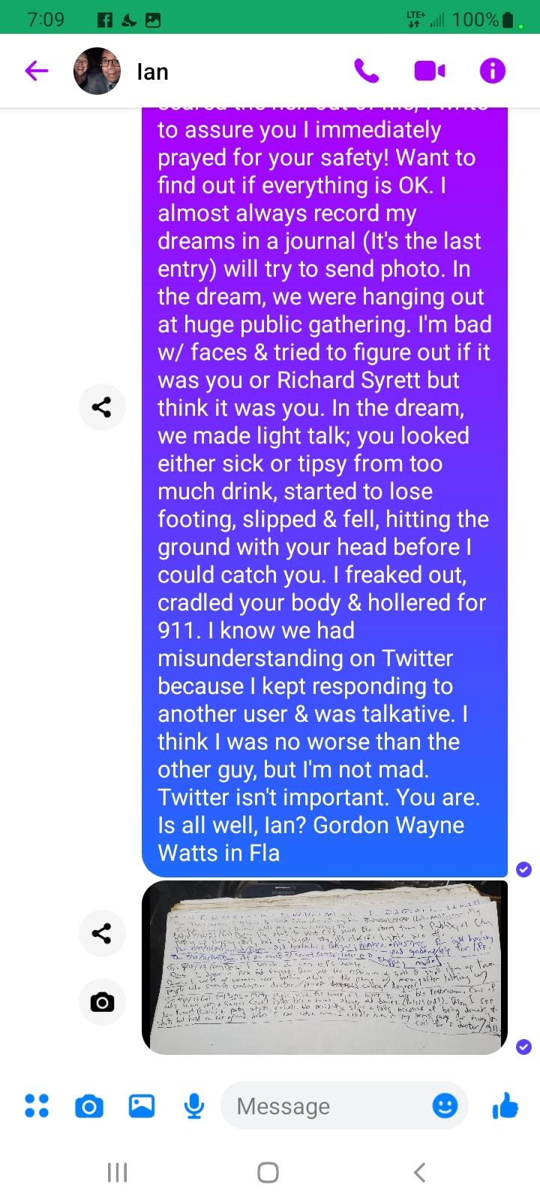
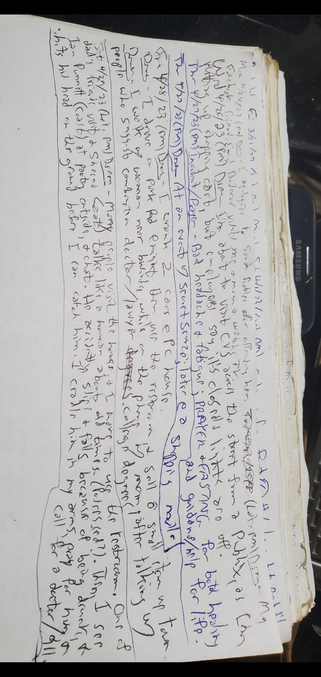

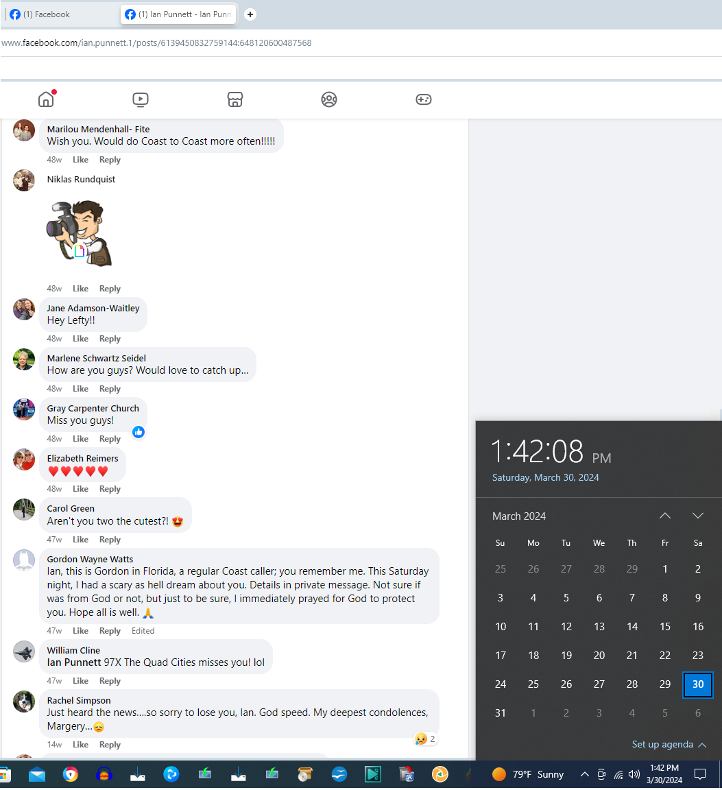

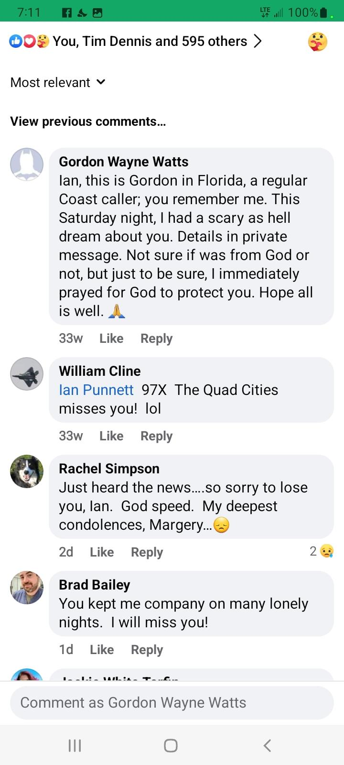

Index of Appendices:
- APPENDIX-A: prior dreams fulfilled with startling accuracy
- APPENDIX-B: my dream about Ian; documented proof dream occurred before fulfillment
- APPENDIX-C: other dreams I've had that I feel we should keep any eye on
- APPENDIX-D: info on whether we should test the spirits (and how to do so)
- APPENDIX-E: Frequently Asked Questions (FAQs)

** APPENDIX-C: other dreams I've had that I feel we should keep any eye on **

SUMMARY: These dreams depict several surprising things, including Trump picking Rand Paul as VP running mate, Chinese economic warfare by dumping lots of US Dollars on the market, and GOP lawmakers turning over a new leaf regarding key legislation – cutting certain “liberal” pork spending – and obeying the U.S. Constitution's requirements for bankruptcy uniformity as it applies to collegiate debt – The UNIFORMITY CLAUSE – Art. I, Sec. 8., cl.4, is a special case of EQUAL PROTECTION – and not even in the AMENDMENTS – but the actual original articles of the U.S. Constitution. CAVEAT: I have no earthly idea if these dreams are from God (am seeking to “test the spirits”), but these dreams did happen – and, as clarified and well-documented above – many of my prior dreams have been shockingly accurate – even when there was no way I could have known in advance what many of them VERY accurately predicted.

- Friday, 11-8-2013 – DREAM – This dream depicts a Florida Law being passed letting private TV stations see private caller ID info if they agree to keep it private. ANALYSIS: Legally-speaking, this dream seems like a long-shot – not very likely – but stranger things have happened of a similar nature: Lawmakers said it was ok for “news media” to use police scanners to listen to police in a manner that was not allowed for the general public (supposedly trusting news media more than Joe Average Citizen) and codified in 2021 FLORIDA STATE LAWS, CHAPTER 843.16(1), which prohibits installation of a police scanner in a motor vehicle by people who aren't law enforcement – but with a few exceptions, including for “any recognized newspaper or news publication engaged in covering the news on a full-time basis or any alarm system contractor certified pursuant to...”
- Tuesday, 4-21-2015 – DREAM – China dumps lots of U.S. Dollars into the market in an apparent attempt to cause inflation and crash the U.S. Dollar. ANALYSIS: This – if done – would hurt China, too, as America is a major consumer of Chinese goods – but – while I can't say if I know if this dream is true – still, I report that I had this dream, and it is possible. Perhaps, America should become more independent regarding technology, computer chips, food production, supply chain, etc., and maybe this dream is from God with this warning to prepare for economic woes and/or famine – not unlike King Pharaoh's dream (skinny cows eating fat cows, Genesis 41:25-36), which was NOT literal: The 7 skinny cows were symbolic BUT DID INDEED represent 7 years of famine. Hmm...
- Thursday, 8-13-2015 – DREAM – Donald Trump picks Kentucky's junior senator, U.S. Sen. Rand Paul (R-KY) – the son of retired congressman, Dr. Ron Paul (who ran for president a time or so). ANALYSIS: I'm not saying “Thus saith The Lord” that this will happen – BUT, I did have this dream, and – in light of my very accurate track record to this point, it bears review. DISCLAIMER: I have no “inside information,” here – and am equally critical – and disappointed with – all politicians on both sides of the political spectrum, Mr. Trump included.
- Friday, 1-19-2018 – DREAM – I'm at the POWER SHOP gym, in my home town of Plant City, FL (between Tampa & Orlando), but my friend, Deb Callahan (who has a gym in neighbouring, Lakeland, FL – just east of Plant City) is running it. ANALYSIS: This seems possible, but unlikely, as I haven't heard anything on this head – and have no inside information. But anything is possible – and I did have this dream.
- Sunday, 3/19/2023 (AM) – DREAM – My member of Congress, U.S. Rep. Laurel M. Lee (R-FL-15), files 2 bills – one to cut (reduce/ eliminate) “liberal” pork student loan originations spending by the Dept of Ed (to make/ originate “student” loans) – something our GOP Party Platform claims should be done – and another bill to reinstate/ return/ restore constitutionally-protected (Art.I, Sec.8, cl.4, U.S. Const.) bankruptcy uniformity for all collegiate debt – and to serve as a “Conservative” Free Market “check” to force the Dept of Ed to be more reluctant to lend (when they know student borrowers can “defend” in bankruptcy proceedings. ANALYSIS: District 15 is, indeed, slightly “purple” – eg, only slightly “Republican” in its voter base, and this seems tenable – but, as Congresswoman Lee has made no public statement here (and as lawmakers of BOTH parties are eager ONLY to protect THEIR rights to standard consumer protections, like bankruptcy rights – but not for students), this may simply be “wishful thinking” on my part (as I do much news/ commentary/ advocacy here), and not an actual message from God. However, I did have the dream, and my prior track record is well-documented to be exceptionally accurate. ...Time will tell.
- Tuesday, 5-9-2023 (AM) – DREAM – I see Sen. Rick Scott (R-FL) at a public event – and subsequently talk, at length, with Sen. Marco Rubio (R-FL) while we stand outside a house on the northwest area of my neighbourhood block – regarding the “student loan bankruptcy” legislation referenced in the dream journal entry above (dated Sun. 3/19/2023) – and discussed on my personal blogs. Rubio says he'll give me a fair chance and hear me out – and he's glowing very brightly. ANALYSIS: Rubio has, on occasion, made public statements that he has struggled paying of his student debt – now that it's gotten to be super unaffordable nowadays – but – like Lee – has not done anything. As above – this may simply be “wishful thinking” on my part (as I do much news/ commentary/ advocacy here), and not an actual message from God. However, I did have the dream, and my prior track record is well-documented to be exceptionally accurate. ...Time will tell.
- Saturday, 11/4/2023 (Early PM) – DREAM – New houses are being built in the northeast area of my neighbourhood block – and it's getting real crowded (lots more houses). ANALYSIS: Maybe dream from God about new houses due to increased population. “Time will tell.”

Index of Appendices:
- APPENDIX-A: prior dreams fulfilled with startling accuracy
- APPENDIX-B: my dream about Ian; documented proof dream occurred before fulfillment
- APPENDIX-C: other dreams I've had that I feel we should keep any eye on
- APPENDIX-D: info on whether we should test the spirits (and how to do so)
- APPENDIX-E: Frequently Asked Questions (FAQs)

** APPENDIX-D: info on whether we should test the spirits (and how to do so) **

QUESTION: Should we seek to “test the spirits” regarding dreams which are of uncertain accuracy?
ANSWER: This question seems to answer itself – it is basic common sense to see if something is “real.”

QUESTION: How can we test the spirits? (Dreams, here, are referred to as spirits, as they sure aren't people.)
ANSWER: First, most people of faith use their holy book – in my case, the JudeoChristian Bible (Old and New Testaments) as a source for information, so it's a good idea to make sure THE BIBLE is accurate. THEN, we can move on to seeing what it says on the subject – Testing the Spirits.

QUESTION: Is the JudeoChristian Bible accurate?
ANSWER: If there is a creator (how'd we all get here), it seems reasonable He's leave some instruction manual (Bible) – and historians have plenty of Bible manuscripts to research, more than many of the classics (Homer, Caesar, Plato, etc.), and accept them as accurate. Also, Ancient Israeli scribes would not have recorded so many national shortcomings (e.g., "sinful failures") and embarrassing national mistakes (especially Old Testament) is it were not true. Also – Archaeological evidence supports the many claims made in the Bible -such as Noah's Ark found on Mount Ararat, salt foundation remains of Sodom & Gomorrah, etc. Moreover – Biblical scientific claims were accurate. E.g.,
* Burial of dung instead of convenience of leaving it in open is necessary to avoid diseases! “But the flesh of the bullock, and his skin, and his dung, shalt thou burn with fire without [outside] the camp…”-- Exodus 29:14
* Circumcision after EIGHT days (not 7 or 9), since every basic medical student knows that blood clotting factor is maximum on 8th day after birth: “And he that is eight days old shall be circumcised among you…”--Genesis 17:12
* -Earth IS round, as science proved later: “It is he that sitteth upon the circle of the earth, and the inhabitants thereof are as grasshoppers;…”-- Isaiah 40:2

Furthermore, the Bible has stood the test of time, has trustworthy moral life counsel, and has changed lives.

Lastly, Many prophecies both by Jesus AND about Jesus -and world events -have been fulfilled with startling accuracy!
*** One example: Ezekiel 37:21, 22 predicts that Israel will be re-gathered & reborn as a nation -and Isaiah 66:7-8 goes on to add that Israel will need only one day to be reborn!
*** Never in the history of the world had such a thing happened before--but God keeps His word. As definitely foretold here and in Ezekiel 37:21, 22, Israel became a recognized nation, actually "born in one day." After being away from their homeland for almost 2,000 years, the Jews were given a national homeland in Palestine by the Balfour Declaration in November, 1917. In 1922, the League of Nations gave Great Britain the mandate over Palestine. On May 14, 1948, Great Britain withdrew her mandate, and immediately Israel was declared a sovereign state, and her growth and importance among nations became astonishing.

For further reading: “SPECIAL REPORT: Exploring Reincarnation, Past Lives, and the accuracy of the Bible:,” The Register, Tuesday, 09 June 2009, LINKS:

https://www.GordonWatts.com/theology/reincarnation.html

https://www.GordonWayneWatts.com/theology/reincarnation.html

https://Archive.ph/6lz7Y

https://Web.Archive.org/web/20230320064109/https://www.gordonwatts.com/theology/reincarnation.html

QUESTION: If we accept the JudeoChristian Bible accurate, then what are means to “test” the spirits here?

ANSWER:

- SPECIFIC TEST OF RIGHTEOUSNESS: Angel or “Prophet” must be righteous, specifically regarding not denying Jesus: (I John 4:1-3: “Beloved, believe not every spirit...because many false prophets are gone out into the world.”) This applies only to spirits (like angels and dreams), not humans – who can deny Jesus (example: Peter DENIED Jesus Christ in the strongest possible terms thrice, that is, three times: Matthew 26:34, 75; Mark 14:30, 72; Luke 22:34, 61; John 13:38), probably because fallen angels (demons) are much more sensitive to retaliation in the spirit work from the devil if they confess. The demons believe – but can't confess – see JAMES 2:19: Thou believest that there is one God; thou doest well: the devils also believe, and tremble. However, none of my dreams listed above featured spirits which were questioned as to whether they confessed fealty/ loyalty to Jesus. [[This test applies to ANGELS or SPIRITS – not people – just the opposite as test 2, below.]]

- GENERAL TEST OF RIGHTEOUSNESS: The general lifestyle of the prophet must be righteous. In this case, I'm claiming to speak for The Lord accurately – and only say what The Lord says – and no more (so far, I have been very careful to not speculate when I don't know), so this applies to me: “15 "Beware of false prophets, which come to you in sheep's clothing, but inwardly they are ravening wolves." 16 "Ye shall know them by their fruits..." (Matthew 7:15-16a, KJV) WHAT ARE THEIR FRUITS, you wonder?” – While I'm not perfect, most accept my lifestyle as righteous – not sinful – so there is no apparent problem here. [[This test applies to PEOPLE – not ANGELS or SPIRITS – unless you can get to know an angel over a period of time... very unlikely.]] CAVEAT: Sometimes, even “evil” prophets can do miracles – so, we must apply one more standard of righteousness: Do they ask you to go against The Lord – and disobey Him? CITATION: Deuteronomy 13:1-5, KJV: {13:1} If there arise among you a prophet, or a dreamer of dreams, and giveth thee a sign or a wonder, {13:2} And the sign or the wonder come to pass, whereof he spake unto thee, saying, Let us go after other gods, which thou hast not known, and let us serve them; {13:3} Thou shalt not hearken unto the words of that prophet, or that dreamer of dreams: for the LORD your God proveth you, to know whether ye love the LORD your God with all your heart and with all your soul. {13:4} Ye shall walk after the LORD your God, and fear him, and keep his commandments, and obey his voice, and ye shall serve him, and cleave unto him. {13:5} And that prophet, or that dreamer of dreams, shall be put to death; because he hath spoken to turn [you] away from the LORD your God, which brought you out of the land of Egypt, and redeemed you out of the house of bondage, to thrust thee out of the way which the LORD thy God commanded thee to walk in. So shalt thou put the evil away from the midst of thee.

- SPECIFIC TEST OF ACCURACY: The specific “prophecy” or “revelation” must be accurate – 100%. This would apply if I were to say “Thus saith The Lord” (and I may later), but as I have not claimed to know if the unfulfilled dreams are from God (i.e., if God really sent those dreams to predict future events), then this test is moot – but since I may LATER claim to hear from the Lord, let's take a look at this test: This is the “classic” test or the “gold test” of a “true prophet”: Does the prophecy or prediction come true? (Deuteronomy 18:22) If the “prophet” or “angel” or dream or vision says anything false about things past, present, or future, you can scratch it: “If what a prophet proclaims in the name of the LORD does not take place or come true, that is a message the LORD has not spoken. That prophet has spoken presumptuously. Do not be afraid of him.” (Deuteronomy 18:22, NIV, New International Version: © Copyright © 1973, 1978, 1984 by International Bible Society) “When a prophet speaketh in the name of the LORD, if the thing follow not, nor come to pass, that is the thing which the LORD hath not spoken, but the prophet hath spoken it presumptuously: thou shalt not be afraid of him.” (Deut. 18:22, KJV) [[THIS TEST MAY APPLY TO PEOPLE AND SPIRITS ALIKE.]]

- GENERAL TEST OF ACCURACY: The “general” method of contact with the spirit world must be accurate, not prohibited. Is the general prophecy a method permitted by God, that is, did the "prophet" use a forbidden witchcraft method to call up the spirit, or did it appear in one of the permitted ways, such as a vision or an angelic visitation? (Deuteronomy 18:10-12) Don’t cheat. Cheating, like taking drugs, may seem good for a while, but in the end, it is deadly. Deuteronomy 18:10-12, KJV 10 There shall not be found among you any one that maketh his son or his daughter to pass through the fire, or that useth divination, or an observer of times, or an enchanter, or a witch. 11 Or a charmer, or a consulter with familiar spirits, or a wizard, or a necromancer. 12 For all that do these things are an abomination unto the LORD: and because of these abominations the LORD thy God doth drive them out from before thee. Huh? What’s a “necromancer?” Think “Necrosis, tissue death.” Let’s look at this passage in another version to get clarity: Deuteronomy 18:10-12, NKJV 10 There shall not be found among you anyone who makes his son or his daughter pass through the fire, or one who practices witchcraft, or a soothsayer, or one who interprets omens, or a sorcerer, 11 or one who conjures spells, or a medium, or a spiritist, or one who calls up the dead. 12 For all who do these things are an abomination to the LORD, and because of these abominations the LORD your God drives them out from before you. If you ask God for an answer via, say, calling up and “speaking with” the dead -or the Ouija board -or even astrologers and horoscopes, then any answer you get may be -and probably will be from a demon, not God or His Holy angels. [[APPLICABILITY: The Lord sometimes speaks through dreams – especially in the last days (Joel, chapter 2, Acts, chapter 2), and The Lord changes not (Malachi 3:6) and is the same yesterday, today, and forever (Hebrews 13:8), so there is no problem here, so long as I don't attempt prohibited necromancy or witchcraft means to get a message from the spirit world. I did not.]]

- 'MIRACLE' TEST: True prophets (and holy angels of God) should sometimes perform miracles to verify their veracity that they are genuine: True prophets *must* perform miracles -at least a few -and not just prophets, but ANY and ALL believers, but this must include prophets -especially. “17 And these signs shall follow them that believe; In my name shall they cast out devils; they shall speak with new tongues; 18 They shall take up serpents; and if they drink any deadly thing, it shall not hurt them; they shall lay hands on the sick, and they shall recover.” MARK 16:17-18, KJV – and, as shown above, many of these dreams are so accurately correct that there is no doubt that The Lord is in it.

- 'APPLICABILITY' TEST: The prophecy (from either prophet or angel) must not only be accurate but also applicable to do a good work of God. – The New Testament version of the 'accuracy' “Gold Test” from Deuteronomy 18:22 is found in James 1:17, which reads: “Every good gift and every perfect gift is from above, and cometh down from the Father of lights, with whom is no variableness, neither shadow of turning.” in the KJV, but it is more clear in the NKJV (New King James Version) and reads as follows: “Every good gift and every perfect gift is from above, and comes down from the Father of lights, with whom there is no variation or shadow of turning.” I have provided both the NKJV and the KJV, so please don’t think I’m pushing one version or using a Bible that translates wrong! I used both to be safe. OK, I’ll translate: If the prophecy is both good (helpful) and perfect (mature or correct and complete), then it is from God. It must be not just correct but also helpful to apply to your need. NOTE: Many of these dreams are indeed applicable – and not just predicting what colour socks someone is going to wear the next day.

- HOLY SPIRIT TEST: There must be a witness of the spirit in the believer, who listens for the check in the spirit. Is there the testimony of the Holy Spirit, a gut feeling, so to speak? (Psalms 95:7-11; Proverbs 1:20; John, chapter 10; Hebrews 3:7; Hebrews 4:7) His sheep (us) hear his voice (the Holy Spirit), so we must chill out and listen carefully, however, we many be tricked, so we must use ALL these tests in order to get a good handle and “fine-tune” our intuition, our gut feeling, our ability to hear and understand the Holy Spirit.

- BONUS: I noticed I'd overlooked a few other helpful tips to hearing from God, in my old 2016 paper, cited below (such as if you pray to God asking if my dreams are true or not – and if I'm acting in good faith and being honest or not: The fear (reverence, respect, and awe) of The Lord is the beginning of wisdom (PROVERBS 1:7), and God stores up knowledge for the righteous (PROVERBS 2:7), – AND: “Study to shew thyself approved unto God, a workman that needeth not to be ashamed, rightly dividing the word of truth.” (II TIMOTHY 2:15, KJV), so if you wanna help your spiritual ears, have a healthy fear/respect for God, be righteous, and study hard – study The Word of God – and the news of the day, to say up to day and not clueless. Plus, be patient: at least FOUR patriarchs of the Bible didn't know what was going on when The Word of The Lord initially came to them: The prophet Samuel (I Samuel, chapter 3) didn't know it was The Lord the first three times The Lord spoke, and needed a 4TH try. King Pharaoh's dream (skinny cows eating fat cows, Genesis 41:25-36) was confusing initially, and he needed help from Joseph. King Nebuchadnezzar's dream (a statue, Daniel, chapter 1—2) was so confusing that he actually FORGOT his dream, and needed help from Daniel. Lastly, Peter's dream/vision regarding unclean food (Acts 10:9-18) wasn't understood right away – so, be patient, grasshopper – wait on the Lord, and keep seeking/ asking, knocking (MATTHEW 7:7-12) to get an answer.

For further reading: “The 7-pronged GOLD TEST for Prophets & Spirits,” The Register, Updated as of Wednesday, 09 March 2016, LINKS:

https://GordonWatts.com/theology/TestForProphetsAndSpirits.html

https://GordonWayneWatts.com/theology/TestForProphetsAndSpirits.html

https://Web.Archive.org/web/20220902094714/https://gordonwatts.com/theology/TestForProphetsAndSpirits.html

https://Archive.ph/f629N

Index of Appendices:
- APPENDIX-A: prior dreams fulfilled with startling accuracy
- APPENDIX-B: my dream about Ian; documented proof dream occurred before fulfillment
- APPENDIX-C: other dreams I've had that I feel we should keep any eye on
- APPENDIX-D: info on whether we should test the spirits (and how to do so)
- APPENDIX-E: Frequently Asked Questions (FAQs)

** APPENDIX-E: Frequently Asked Questions (FAQs) **

Q: Can't the many accuracies be explained by your subconscious seeing things (like a Facebook friend is talkative – and “knowing” she'd ask to meet you in person – or seeing a painter helper acting a bit mad at not being allowed to drink and energy drink – and “seeing” he'd quit or get fired)?
A: The subconscious mind is VERY powerful – but – really – knowing – or seeing – or dreaming – someone would quit or get fired the very next day... highly unlikely. And, with close to FOUR (4,000) THOUSAND Facebook friends – many VERY outgoing – and only dreaming about one asking to meet you who later does... very unlikely. And, my dream about my friend, Ian Punnett – which was so compelling that I pushed real hard to warn him (to be careful when he walked, and not trip/ fall – is what I was trying to say)... I practically NEVER see people lose their lives – or come very close to it – and my young friends almost NEVER pass away. While the dream may have been symbolic (if he didn't literally trip and fall) – nonetheless, it was not unlike the many Bible dreams that used CLEARLY UNDERSTOOD symbolic language. – It was very unlikely, but it came to pass.

Q: How can you support a dream if it doesn't actually do something helpful? Why would God tell you about something if there was “no hope?”
A: First of all, the correct fulfillment lets people know there really is a God who can reveal the future – and do miracles (Bringing Glory to God – and showing people He exists – is NEVER bad.) Secondly, if my message reached Ian, it clearly would be

Q: Why do you plan to contact Ian's wife and family if it will only remind them of their loss and be “depressing?”
A: In assessing this, I sought counsel, prayed, and found guidance in the “golden rule,” which is repeated by both MOSES (in the Old Testament: Leviticus 19:18b, Leviticus 19:34) and JESUS (in the New Testament: Matthew 22:39b, Mark 12:31b, Luke 6:31, Matthew 7:12) – which basically says treat others as YOU'D want to be treated. First, I lost my father, the late Bobby Watts (b.1-27-1935 – d.5-3-2018), and I can assure you that if someone said they'd had a dream, vision, or premonition about dad – either while he was alive – or after he'ds passed – I would want to know both what it was – and (equally or more importantly) and forensic evidence (notes, emails, screenshots, public posts) or eyewitnesses (such as the many cc and bcc recipients of my email to Ian). Secondly, I had a very serious slip/ fall accident MYSELF shortly after arriving home from college, and later a classmate emailed me out of the blue, and said that while he was living in the Bahamas, and mowing grass on a tractor, that he had an overwhelming feeling to stop the tractor and pray for me – and called his pastor too, if I recall correctly. And, this was right around the same time as I'd had that serious accident – and I was very glad not only that my friend took time to pray for me, but also that he let me know about it later. Thus – while I can't speak for Ian's wife, Marjory Punnett – or his sons – nonetheless, I act in good faith when I plan on letting her know what happened on my end. NONETHELESS, any/ all are asked to pray for all of us, so that I am a good steward of God's various opportunities & gifts & talents. (I.e., I feel I let Ian down when I dropped the ball and didn't confirm he got my warning in a timely fashion – however, I am glad that the many times I talked with him – both before and after my dream – were respectful, encouraging, and interesting – and that we didn't let a small misunderstanding distract us from genuine Christian love for others – or the dedication to move forward with our work in life.)

Q: Aren't you just tooting your own horn, here, and bragging about special gifts, etc.?
A: If I were bragging or trying to benefit myself, I would not highlight how MOST of these dreams:
    - were SYMBOLICALLY true (e.g., not literally true)
    - were difficult to understand initially (i.e., I didn't know what they meant initially – like many Bible patriarchs who similarly were confused)
    - Also, if I were trying to be a braggart or self-serving, I would not include the fact that MOST of my dreams were total nonsense and never came true (either literally or symbolically), such as mu Thursday, 11-7-2013 dream which showed my father selling my car and then visiting a friend who worked on a carburetor – and then depicts a 2Nd man with a skull cap fighting a woman at a party and saying she drank some vanilla extract. This dream made no sense – never happened (so far as I can recall) – and now CAN'T happen because my father has passed away.

Q: What do you hope to accomplish by publishing this (lengthy) press release?
A: Since I feel there is a good possibility that some of the “as yet” unfulfilled dreams could come true, I feel it is appropriate to avoid my previous mistakes (where I feel I failed Ian and his family) – but, rather, this time, I hope to be a good steward of my gifts, opportunities, & talents – and publish the startling fulfillment of some of past dreams – provide documented proof the dreams occurred BEFOREHAND and/or detailed description (so others can be questioned, if needed) – and “test the spirits” – so that we're like King Pharaoh, who knew in advance tough times were coming (Genesis 41:25-36) – and was able to take precautions – and save lives. PLUS – these unlikely fulfillment can – hopefully – influence people to draw near to God Almighty – seek Him out – and careful test the spirits by study of The Word and careful attention to detail, and life-lesson of discipline.

Q: Are there still prophets today? Ot, as some have said, have all the supernatural gifts ended since New Testament times? (I.e., if you later claim to be a genuine “prophet,” is that even possible now days?)
A: While some have said that the “gifts” ended with the death of the Bible-era prophets, we still see many genuine miracles nowadays. Moreover, The Lord changes not (Malachi 3:6) and is the same yesterday, today, and forever (Hebrews 13:8), so miracles are still possible. Lastly, any doubters can simply make a check mark by any predictions/ prophecies I make – and see for themselves. – “Time will tell.”

Q: You have said that you were clueless regarding whether any “unfulfilled” dreams above are indeed true – So, what good is your gift? Do you have any ACTUALLY certain prophecies – about the future – or present – or any CERTAIN prophecy and “Word from the Lord?”
A: Yes – I do. Since my dreams about Ian & others were VERY accurate – and well-documented in some cases – this can bring needed attention to me if The Lord wants others to listen to a CERTAIN and ACCURATE message that God is saying – and, as it turns out, I DO have a prediction, prophecy, and will lay my reputation on the line – if it doesn't come to pass, as I say, then (see tests/ standards above, especially, Deut. 18:22), I am a “false prophet,” and can be safely ignored. – Since readers can be assured that I'm smart, honest, and have NO desire to ruin my (otherwise good) name/ reputation, you can bank on my following prophecy IN THE NAME OF THE LORD – eg, “Thus Saith The Lord.”

Here is my prediction – and prophecy – in the Name of The Lord – so pay attention, as this may be your last chance – and The Words of Our Lord are in RED, below:
THUS SAITH THE LORD: “If American 'leaders' (e.g., politicians, lawmakers, others capable of changing policy – as well as news media and influential private citizens who can influence policy makers) don't put an abrupt halt to irresponsible excess spending and printing up of monies, we absolutely – positively – and of a certainty – crash the U.S. Dollar, collapse the American economy, and sink into civil chaos.”

[[[A]]] Note, please, I have not placed a time-table on this prophecy (meaning I know it's correct and true, but don't know when it will happen – and do NOT say something like JONAH did ((JONAH 3:4: “And Jonah began to enter into the city a day’s journey, and he cried, and said, Yet forty days, and Nineveh shall be overthrown.”))

[[[B]]] That said, my personal feeling is that we're “real close” to a total, catastrophic, and complete economic and civil collapse if Americans allow leaders to drop the ball & fail to act. Following are the reasons for both A and B above:

- The CBO has said that the U.S. Student-Loan Program has begun losing money (running a deficit), and that was in early May 2019, even before the Covid-19 Economic Downturn.
- As reported elsewhere, former Sec. of Education, Betsy DeVos, called out the Dept of Ed for its profligate and reckless spending in her 11-27-2018 speech: “Today, FSA's [student debt] portfolio is nearly 10 percent of our nation's debt. [] Stop and absorb that for a moment. Ten percent of our total national debt.” Source: U.S. Dept of Education, Sec. of Education, Betsy DeVos, 11-27-2018 speech. [Editor's Note: Student Debt – at almost 10% – is the largest ares of discretionary spending, thus the lowest hanging fruit to assess as a threat to the economy – and the fault of lawmakers capable of fixing this, not young, powerless high school students forced to take out whatever debt offered to address our current dire shortage of doctors & nurses.]
- The continuing "Debt Ceiling" crisis: If the US defaults on debt, we should expect the dollar to fall – thus causing a descent into civil chaos.
- Many Bible commentators believe that Bible, with its surprisingly accurate predictions in Ezekiel 37:21-22 and Isaiah 66:7-8 that Israel would become a nation after an approximately 2,000-year absence, also predicts hyper-inflation and/or famine in Revelation 6:6, which says that a whole day's wages (denarius or "penny" in KJV) would be needed for a day's ration of food ("quart of wheat"): While, normally, this "proof" of potential hyperinflation or a collapse of the dollar would be restricted to "opinion" or "religion" pieces, nonetheless, The Bible is given credence for its many accurate predictions. One example: Ezekiel 37:21-22 predicts that Israel will be re-gathered & reborn as a nation -and Isaiah 66:7-8 goes on to add that Israel will need only one day to be reborn. However, never in the history of the world had such a thing happened before. But, as predicted and foretold, Israel became a recognised nation, and "born in one day," as predicted. After being away from their homeland for almost 2,000 years, the Jewish People were given a national homeland in Palestine by the Balfour Declaration in November, 1917. In 1922, the League of Nations gave Great Britain the mandate over Palestine. On May 14, 1948, Great Britain withdrew her mandate, and immediately Israel was declared a sovereign state, and her growth and importance among nations became astonishing -- thus adding credibility to the hyperinflation, famine, and economic collapse predictions.
- Navient became the fourth (4th) major student loan servicer to announce an abrupt exist from the U.S. Department of Education's troubled and tumultuous student loan system.
- The COVID-19 Pandemic economic downturn has not only taken a devastating toll world-wide, but moreover, due to recent controversies surrounding vaccine "mandates," many industries are disrupted, experiencing wide-spread "walkouts" and "sickouts," not to mention the overflow experienced by some hospitals which were overrun by COVID patients -- thus directly and indirectly affecting the supply chain and making daily deliveries of many commodities uncertain.
- Grid, weather, emerging solar flare threats, the slow-but-sure collapse of earth's protective magnetic field, pollution, environment, and exponentially-increasing population densities, foreign wars and unrest, and potential EMP attacks, hacking & cybersecurity threats, and such:
- More recently (not reflected in the news coverage below), numerous big banks have failed.

For further reading:

“BREAKING: Fourth (4th) Major student loan servicer quits: Crash of the U.S. Dollar eventual, if not imminent,” by Gordon Wayne Watts, Editor-in-Chief, THE REGISTER, Wed.13 Oct. 2021, LINKS:

https://GordonWatts.com/#crash

https://GordonWayneWatts.com/#crash

https://Archive.ph/0w9bz#crash

https://Web.Archive.org/web/20240331024341/https://gordonwatts.com/#crash

More research on threats that face us due to irresponsible spending, fiat printing, etc.

https://ContractWithAmerica2.com/#pork

https://Archive.ph/laznT#pork

https://Web.Archive.org/web/20240406050301/https://contractwithamerica2.com/#pork

Documented proof that almost all lawmakers, of both parties, are very, very dishonest and don't even make attempts to obey their own party's platform on key issues:

https://GordonWatts.com/HigherEd_OpenInvestigation.html

https://GordonWayneWatts.com/HigherEd_OpenInvestigation.html

https://Archive.ph/4zTf0

https://Web.Archive.org/web/20230529023935/https://GordonWatts.com/HigherEd_OpenInvestigation.html

Just to be clear, I repeat my prediction – and prophecy – in the Name of The Lord – so pay attention, as this may be your last chance – and The Words of Our Lord are in RED, below:

THUS SAITH THE LORD: “If American “leaders” (e.g., politicians, lawmakers, others capable of changing policy – as well as news media and influential private citizens who can influence policy makers) don't put an abrupt halt to irresponsible excess spending and printing up of monies, we absolutely – positively – and of a certainty – crash the U.S. Dollar, collapse the American economy, and sink into civil chaos.”

[[[A]]] Note, please, I have not placed a time-table on this prophecy (meaning I know it's correct and true, but don't know when it will happen – and do NOT say something like JONAH did ((JONAH 3:4: “And Jonah began to
enter into the city a day’s journey, and he cried, and said, Yet forty days, and Nineveh shall be overthrown.”))

[[[B]]] That said, my personal feeling is that we're “real close” to a total, catastrophic, and complete economic and civil collapse.

/Gordon Wayne Watts/
/Gordon Wayne Watts/
Friday, 03 May 2024
///

