Please note in this report: Even the cops admit that the only reason I was asked to leave was for racially prejudiced reasons -and no claim was made that I had disturbed the peace or threatened anyone.-GWW
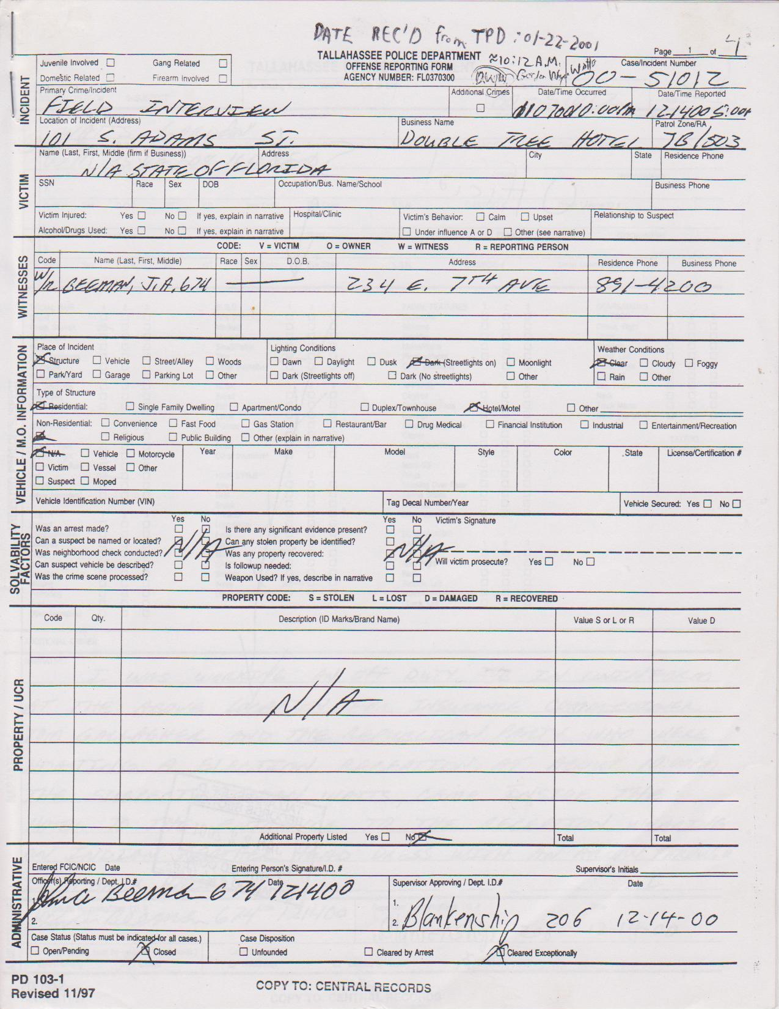
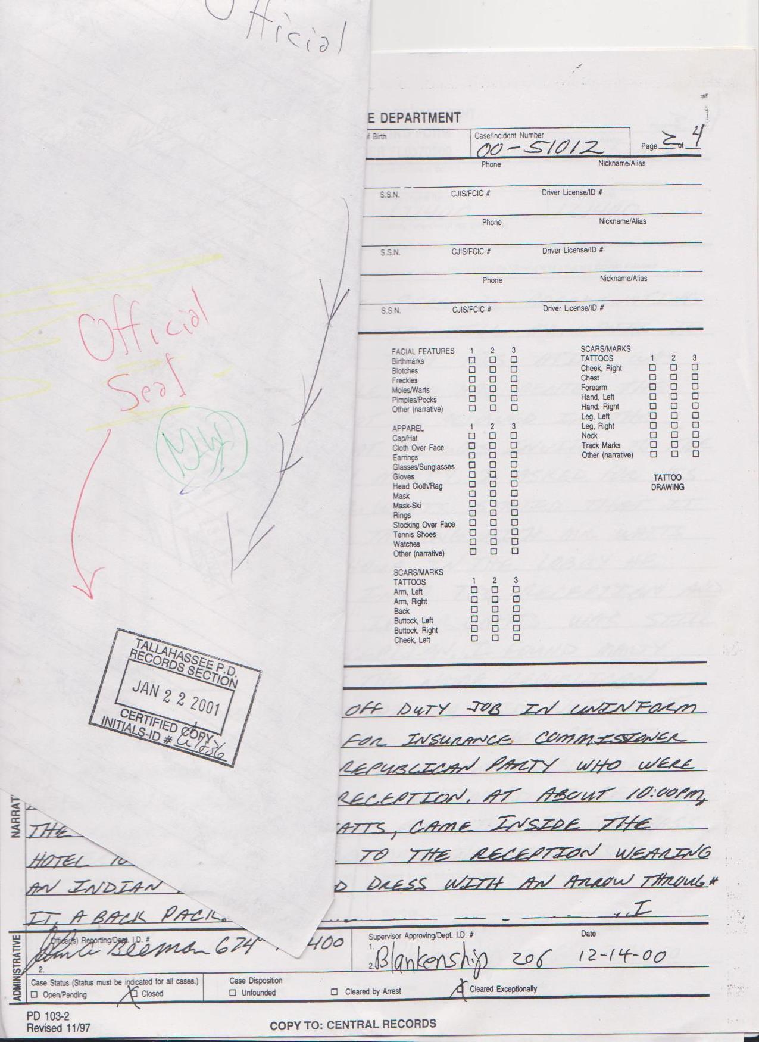

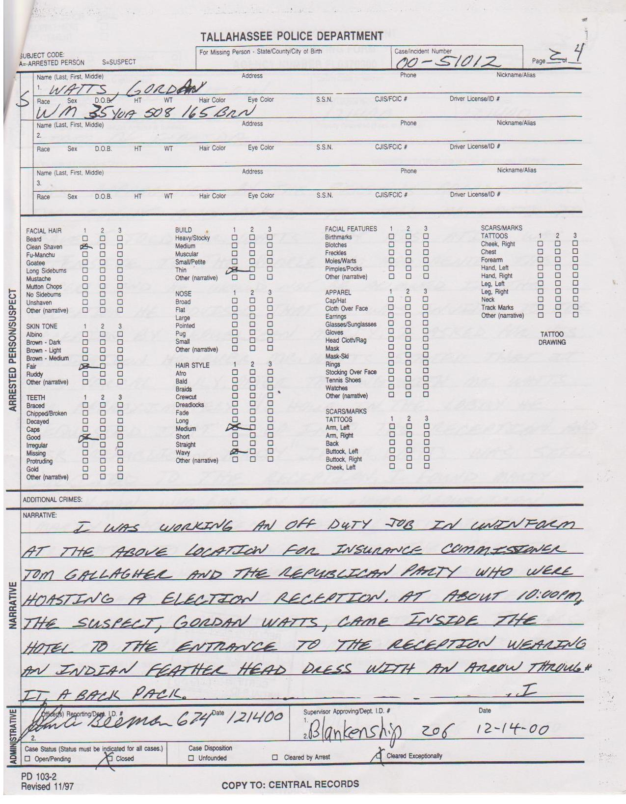

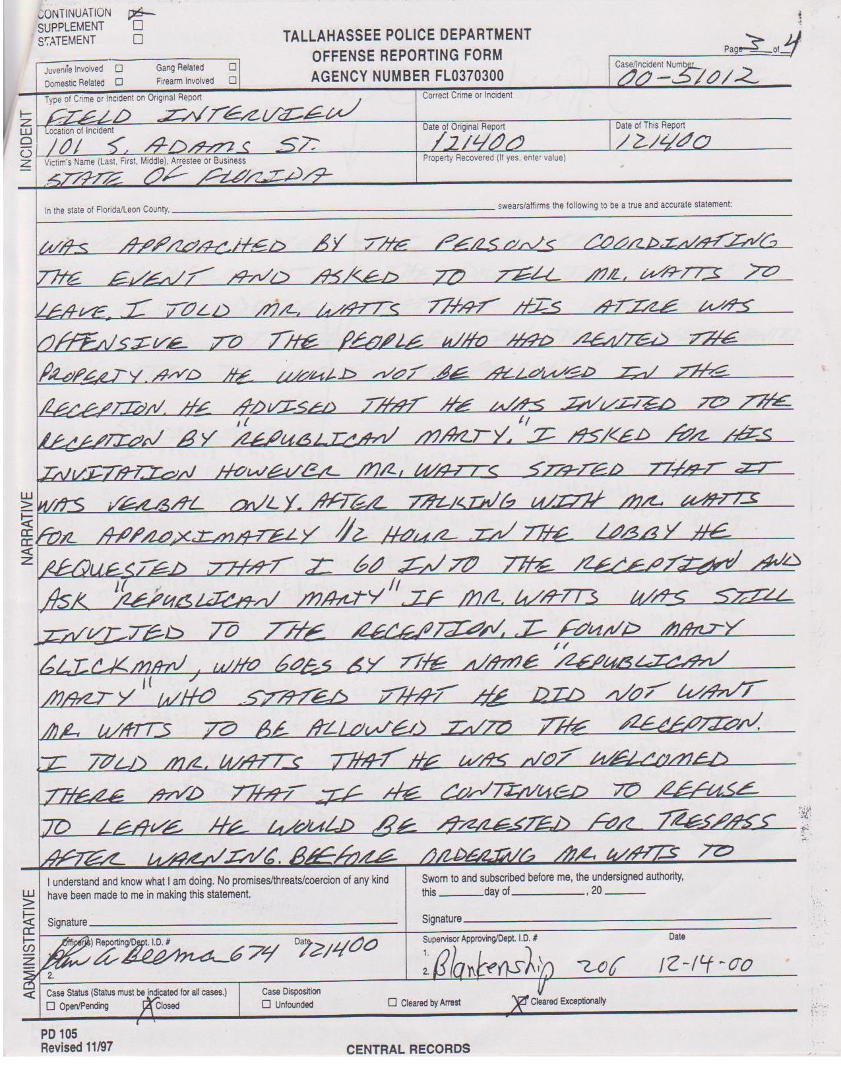

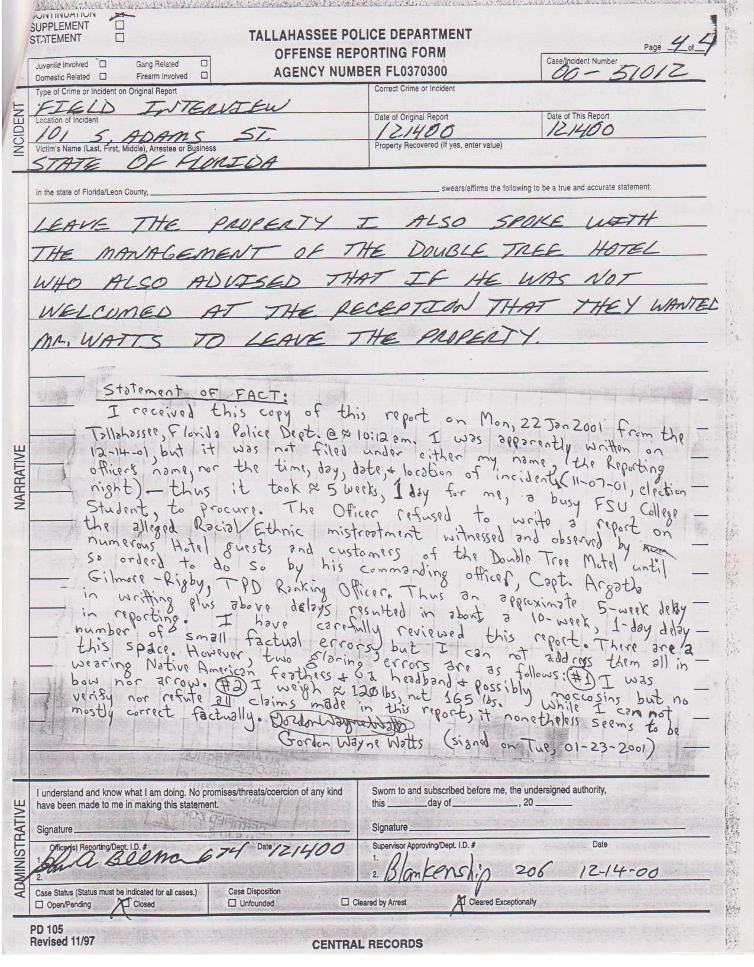

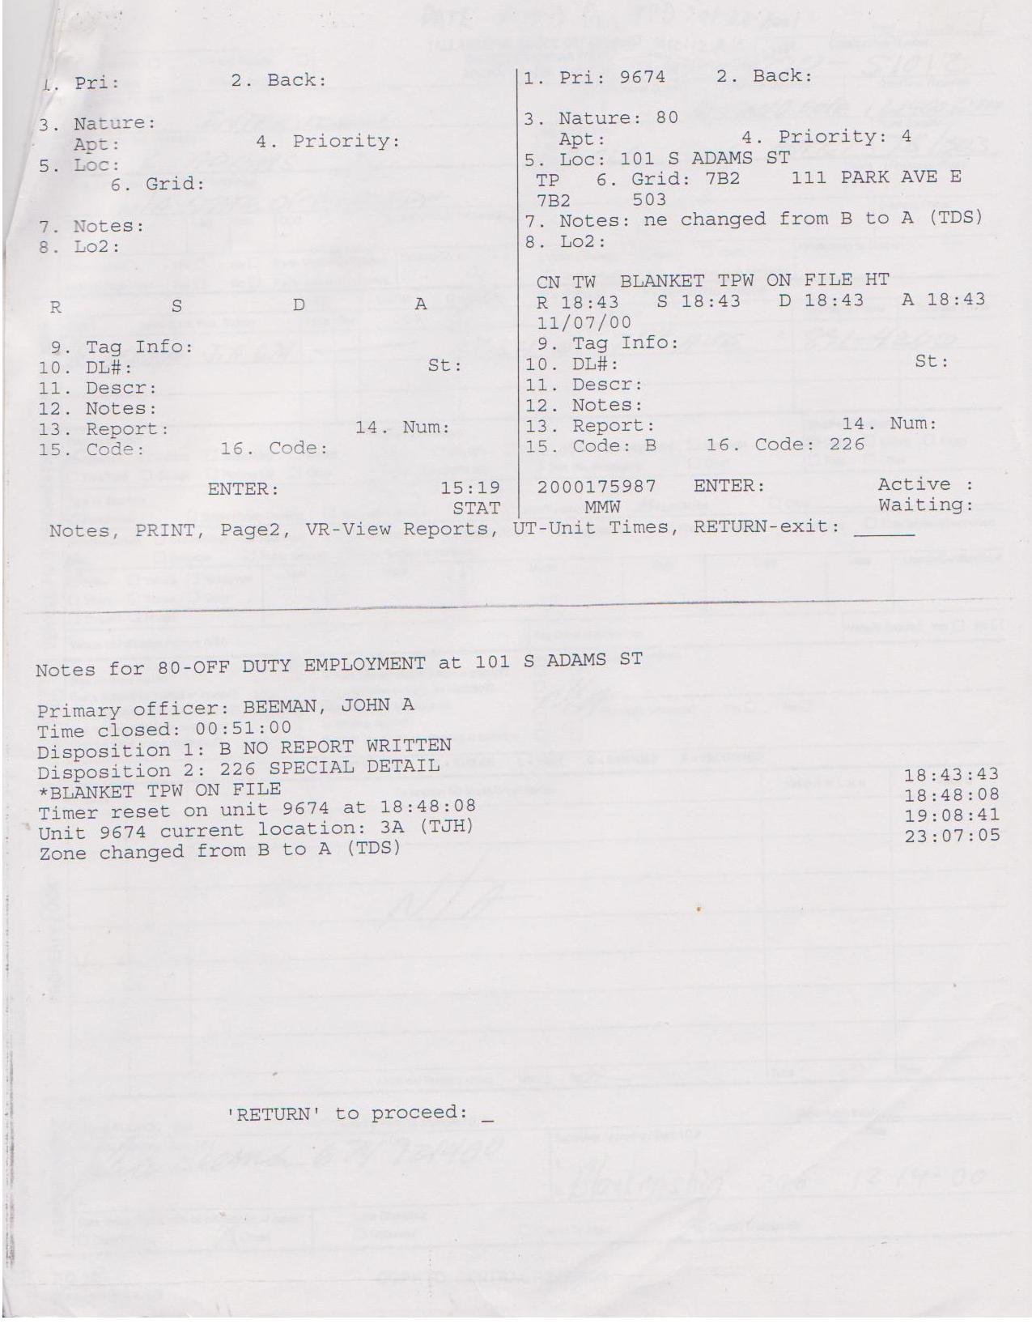
Here, below, is a picture of the late 'Republican' Marty Glickman, named in the report -and, below that, is a copy of an AOL 'Instant Message' conversation with his secretary, Sheila. -GWW
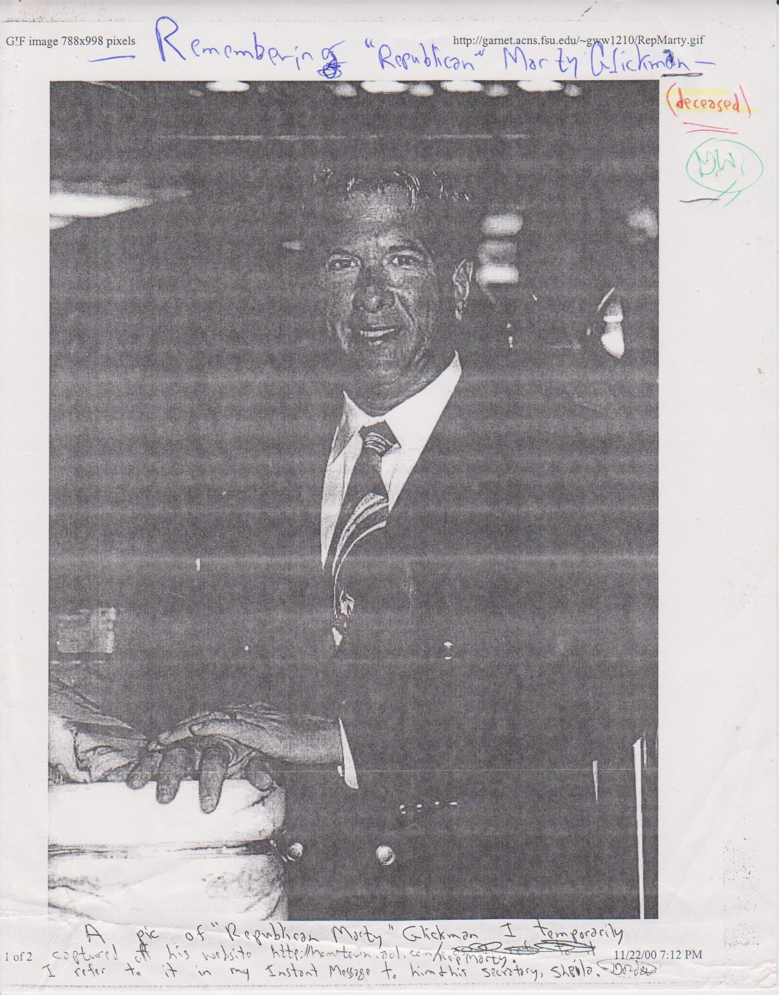
Below is the Instant Message – It was a little longer than 8.5 x 11”, so it may seem to have small print:
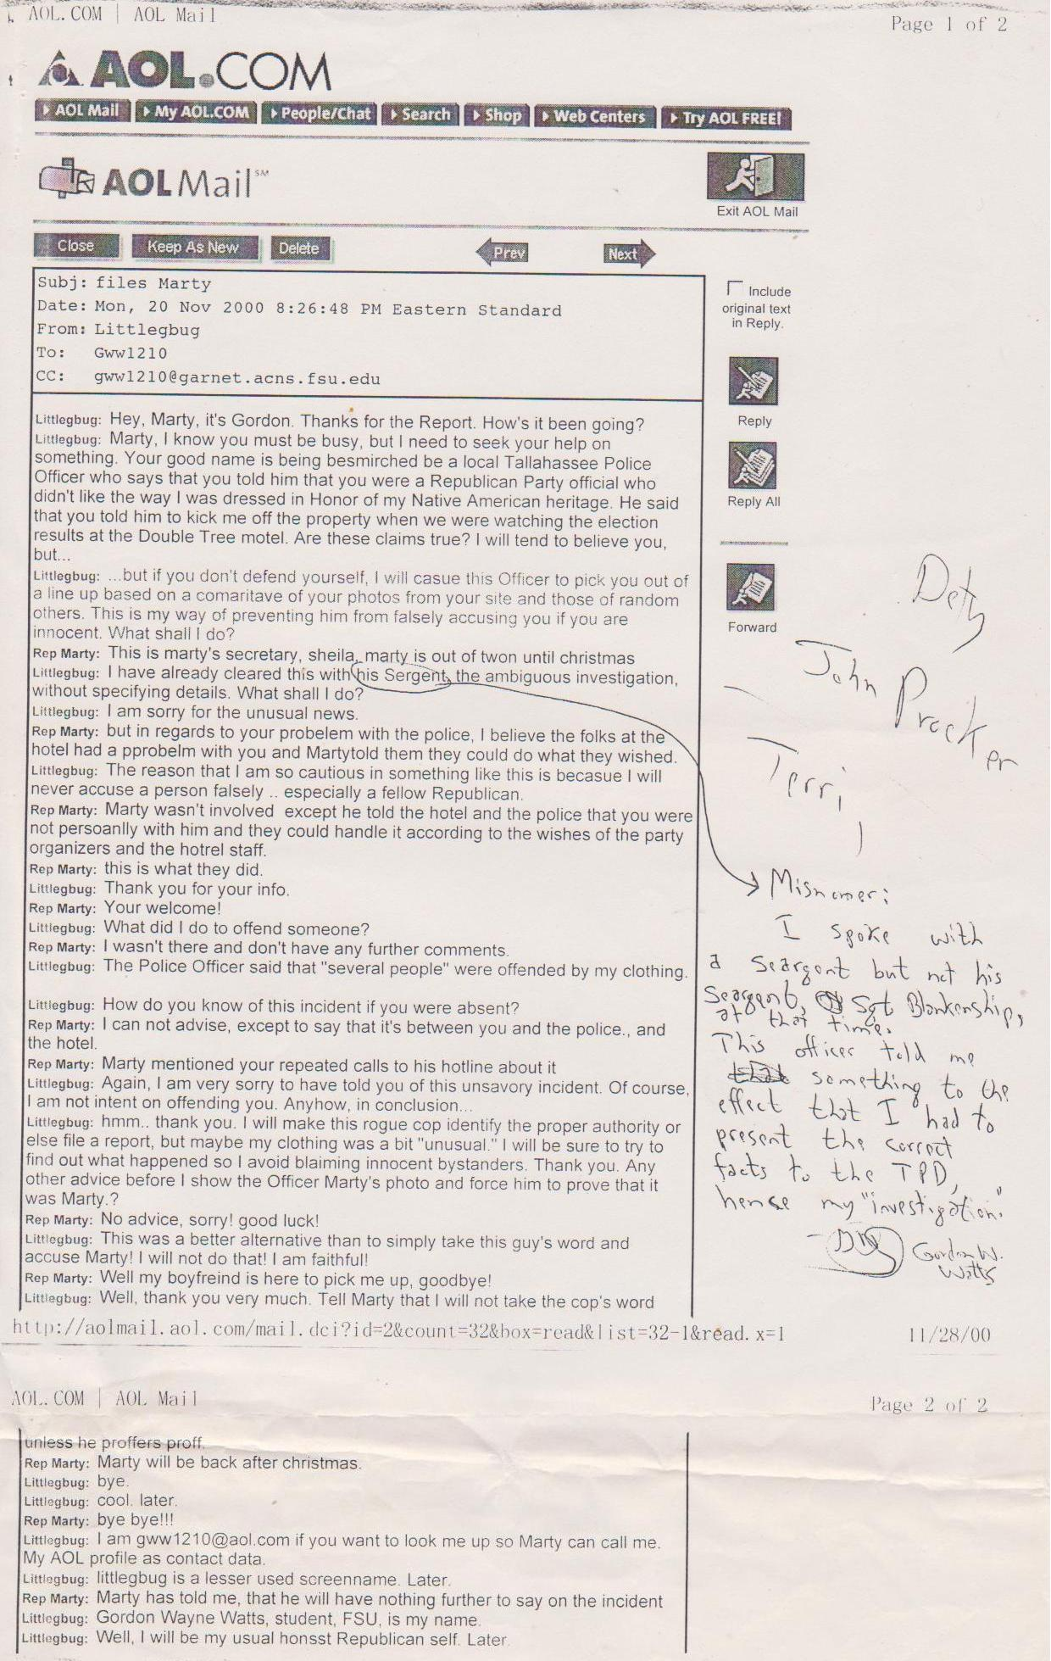
OK, here is the refusal of the FLORIDA State Attorney General's office to do their job.! --LOL--
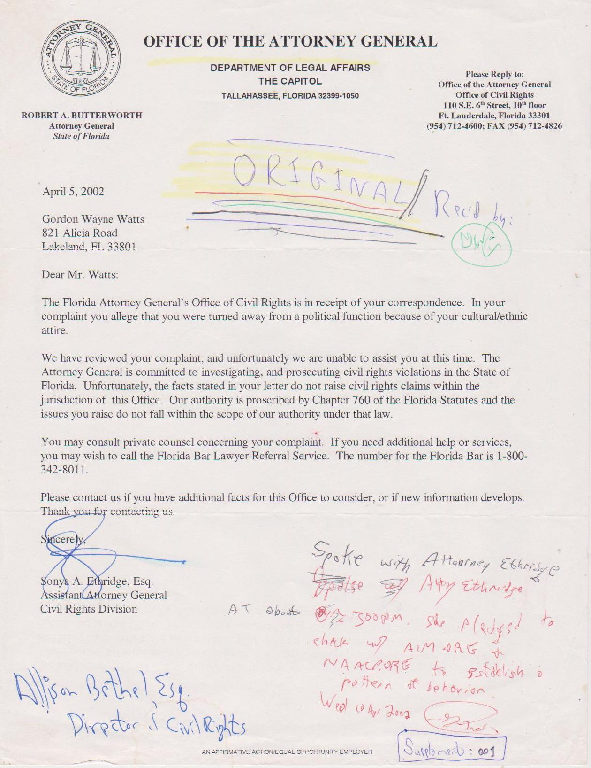
And, my reply... --G.W.W.

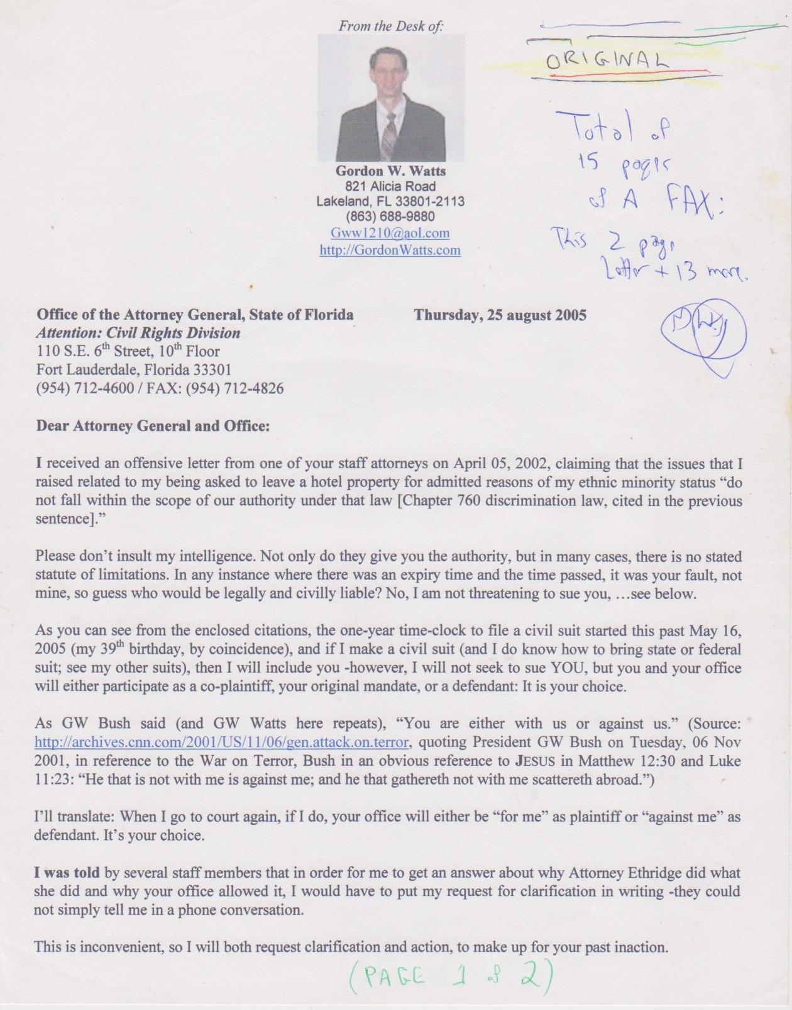

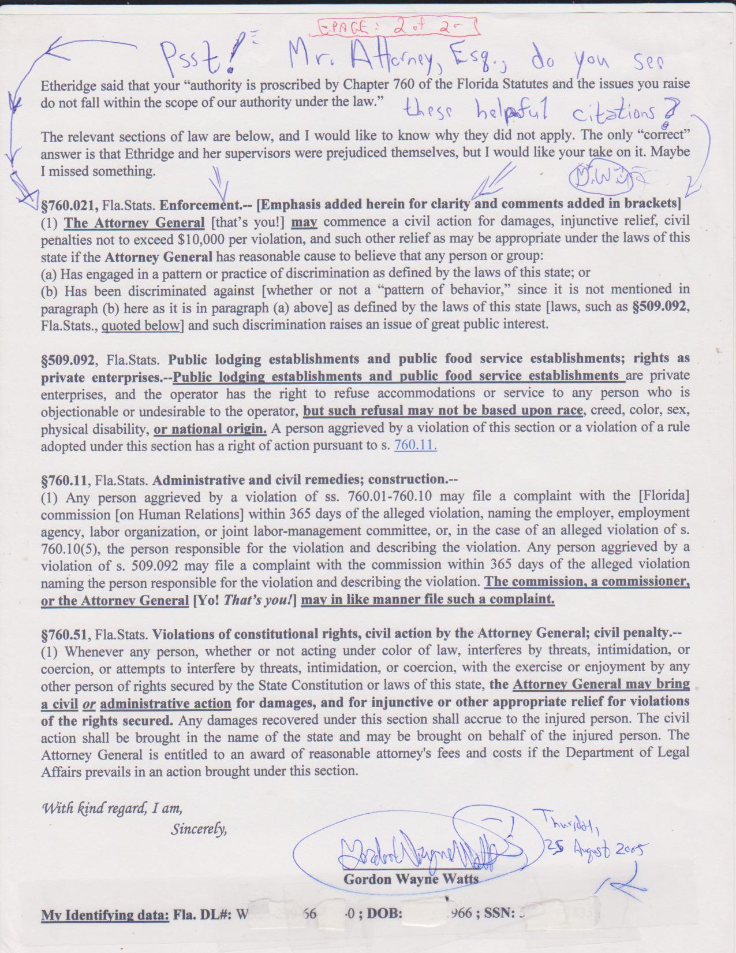
Below is another cowardly reply, still refusing to do their job; however, at least Shamika Graves (Asst Atty General) seems to have been a little more creative & polite than Sonya A. Ethridge, Esq.:
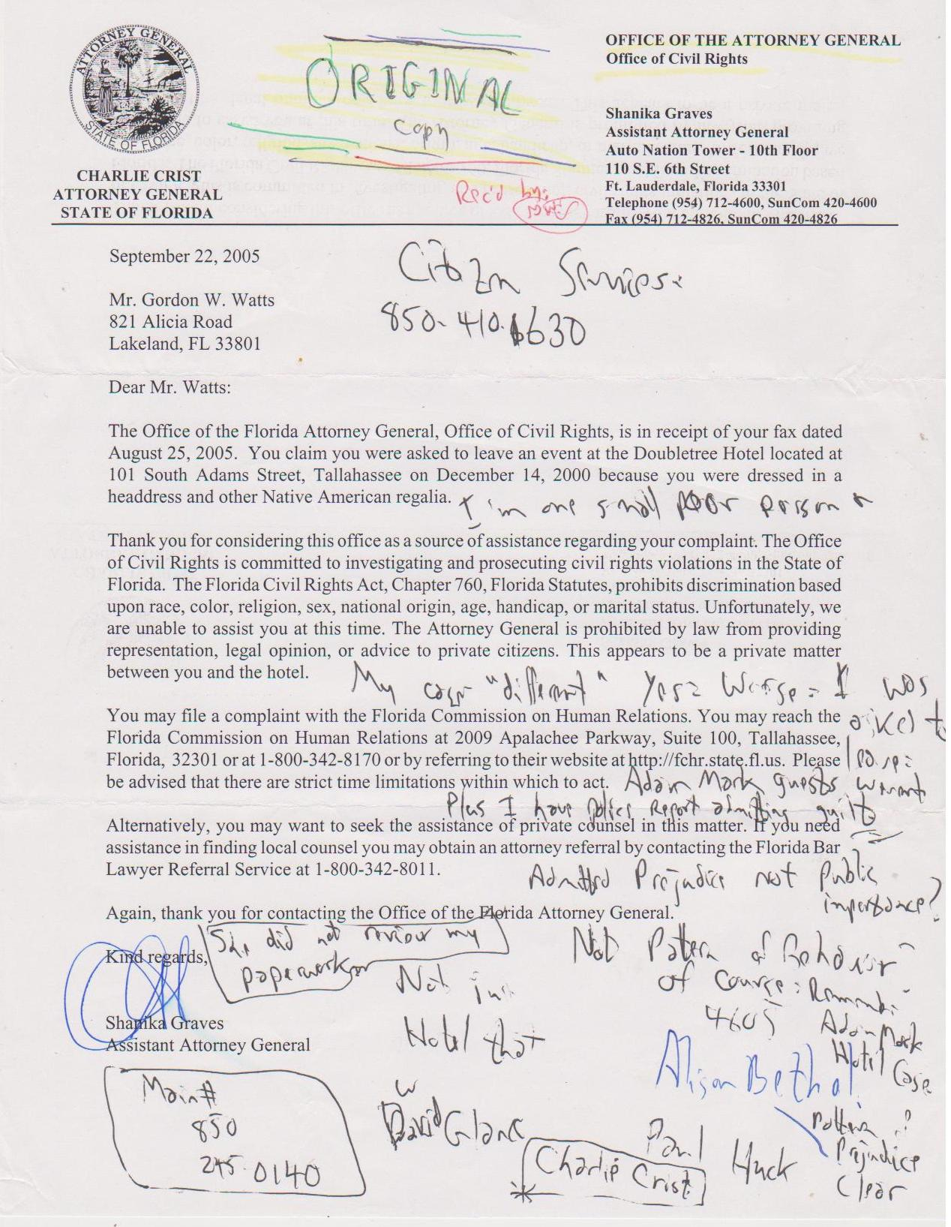
Of course they're wrong: The law is clear – They have done this to help other races such as Blacks:
Please note that the incident below happened at the Adam's Mark resort, while the one below that happened at Best Western. Now, after how they refused to even consider my complaint, regarding the Double Tree Motel incident -also involving the Tallahassee Police Dept's similar civil rights violations, you know why I thought it was a royal waste of time to even bother the FLORIDA Attorney General's office over my complaints regarding the issues at the LAKELAND Police Department, huh?

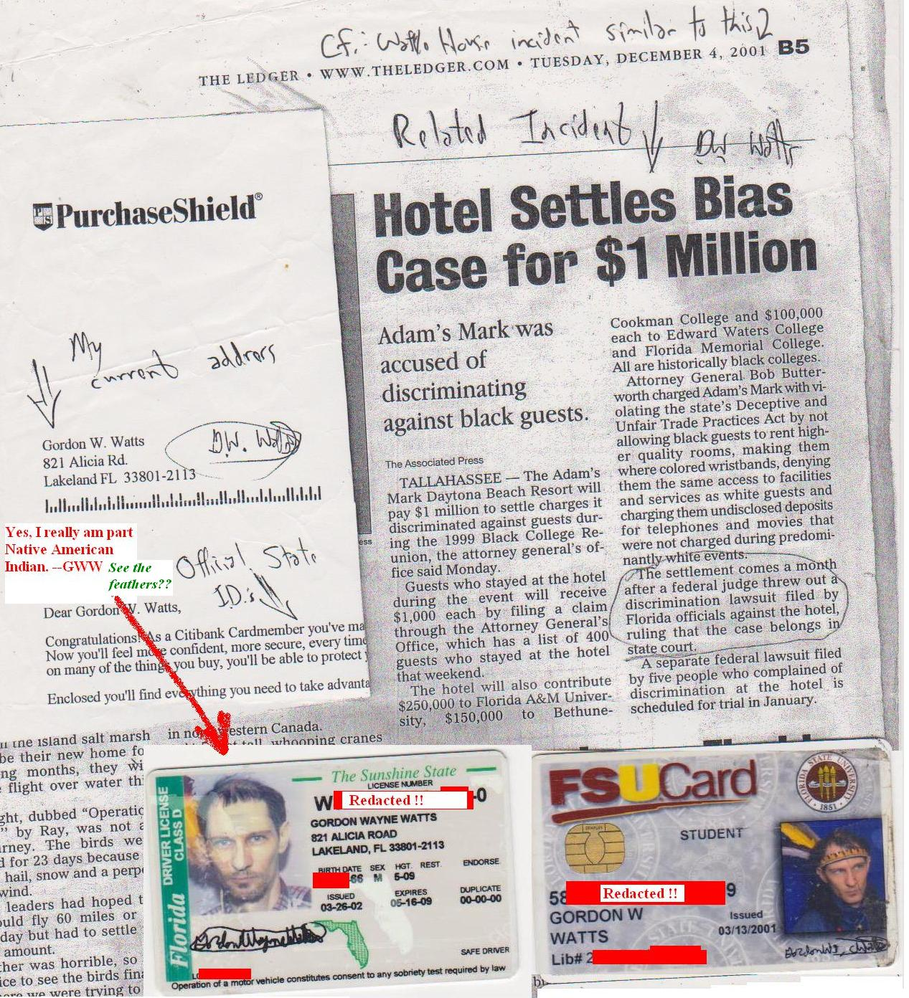

This Thursday, October 17, 2002 Tampa Tribune article below documents that the FLORIDA Attorney General's office *could* take their complaints without incident, so Attorneys, Sonya A. Ethridge and Shamika Graves, Esqs., were just blowing smoke -stonewalling, passing the buck, and/or outright lying. (What's the difference?)

