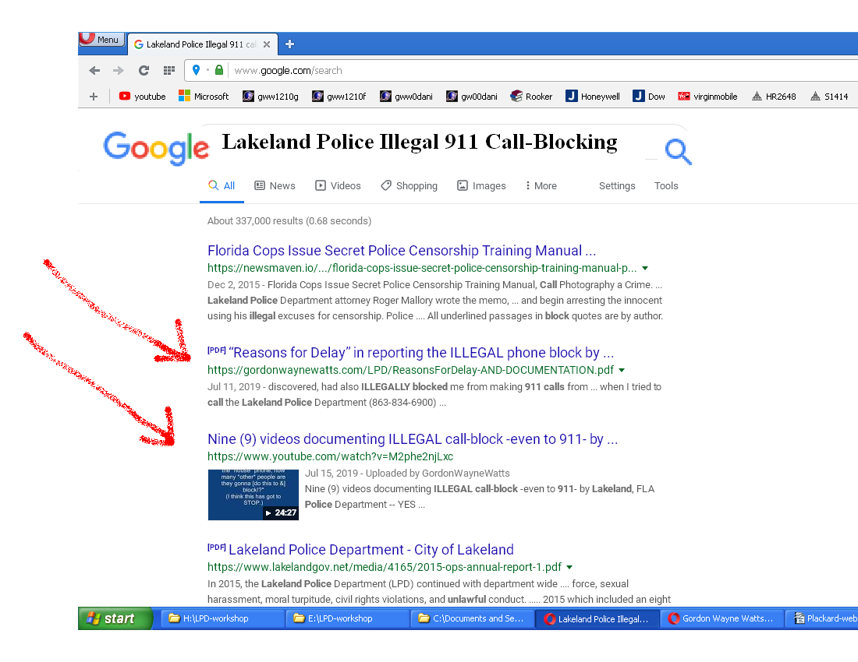

www.GordonWatts.com

or: GordonWAYNEwatts.com

YouTube.com/GordonWayneWatts

Facebook.com/GordonWayneWatts

Twitter.com/Gordon_W_Watts

