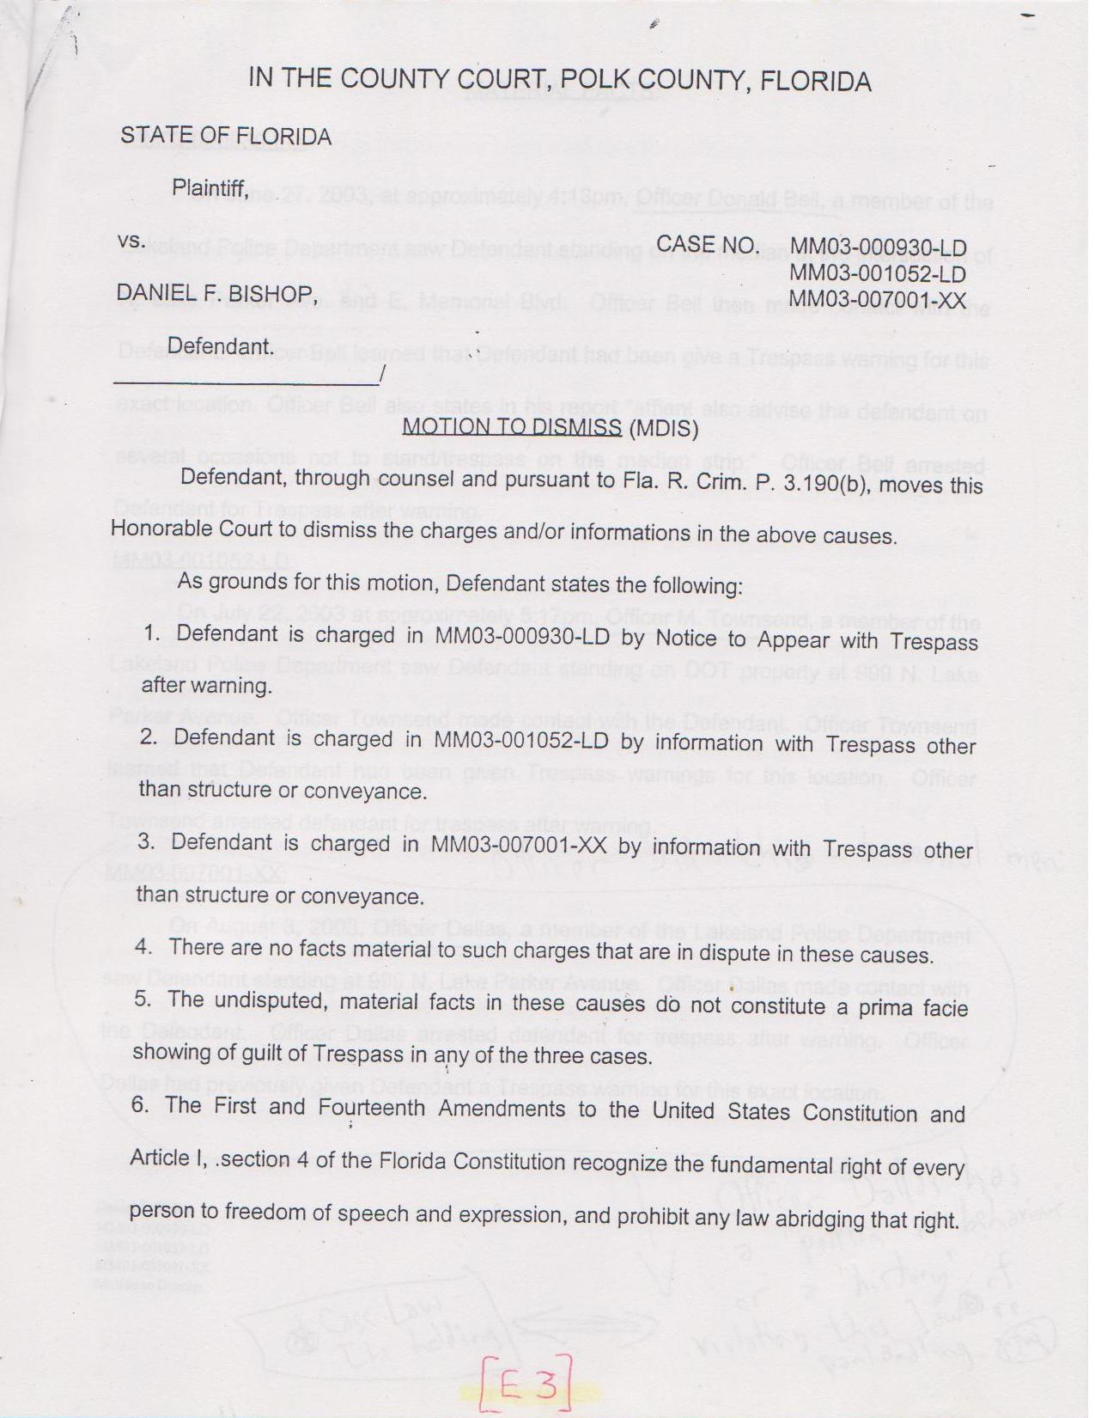

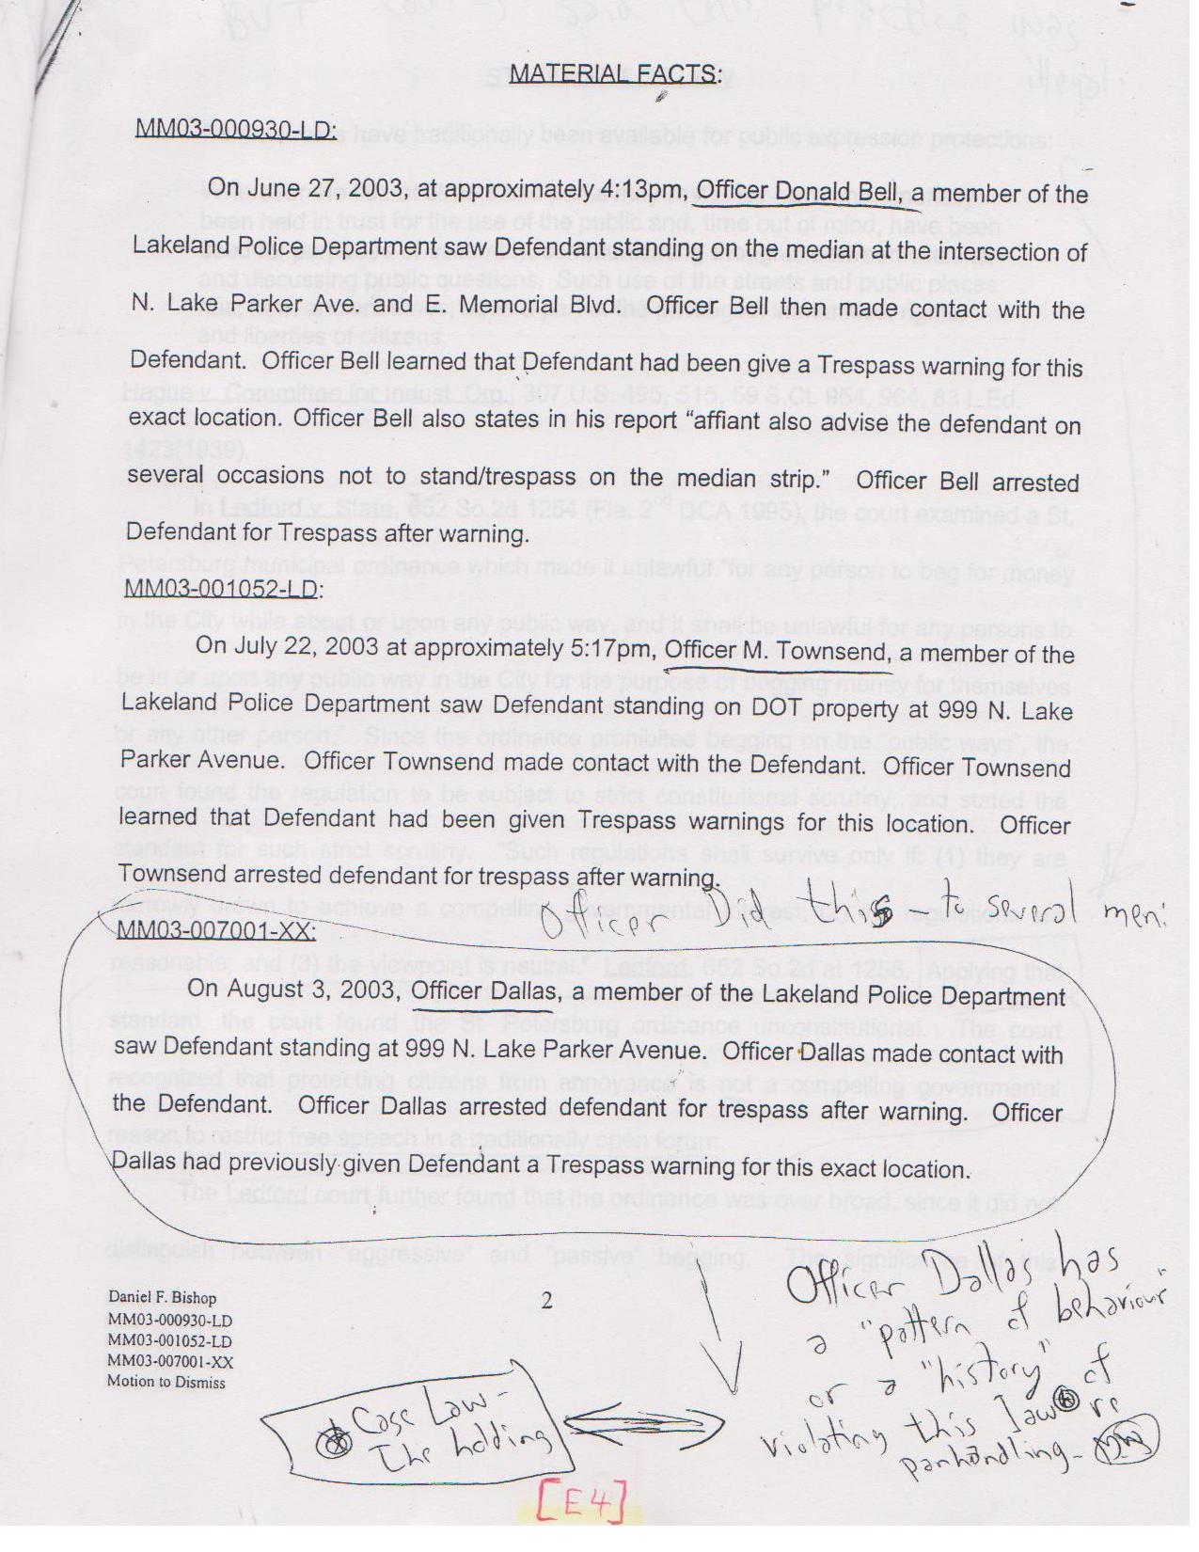

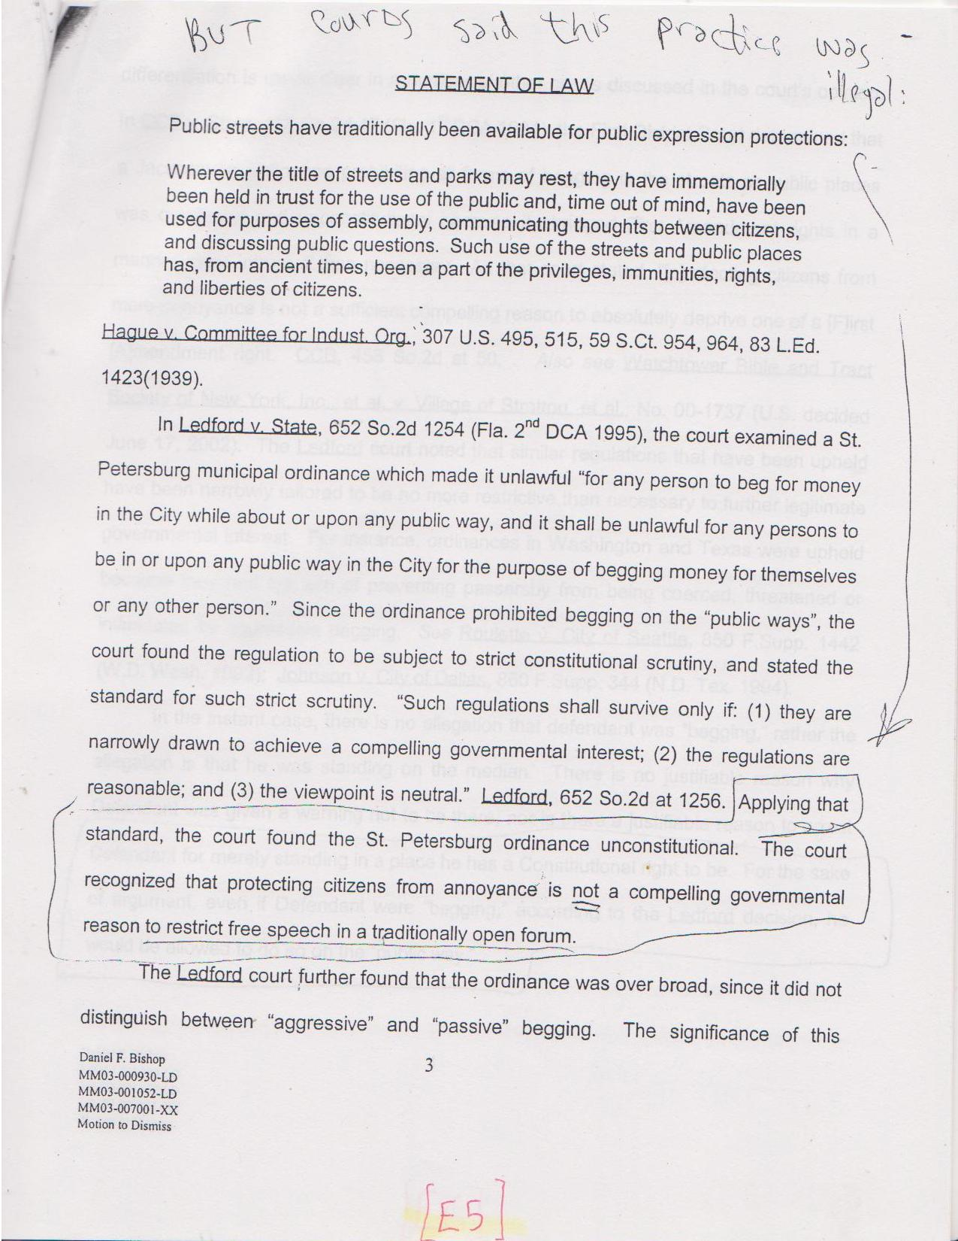

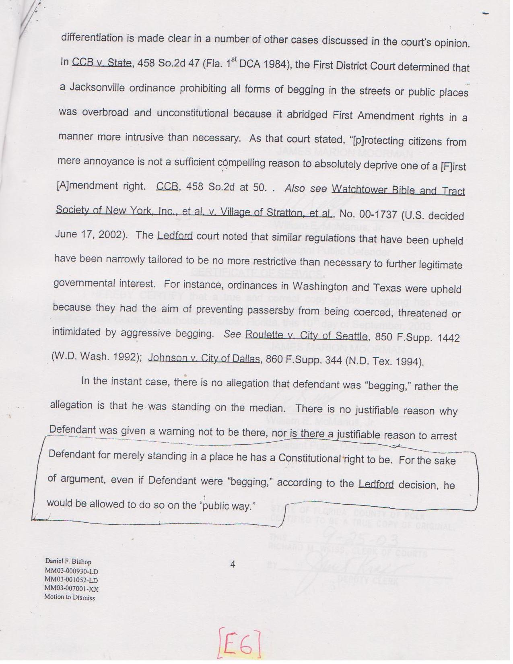

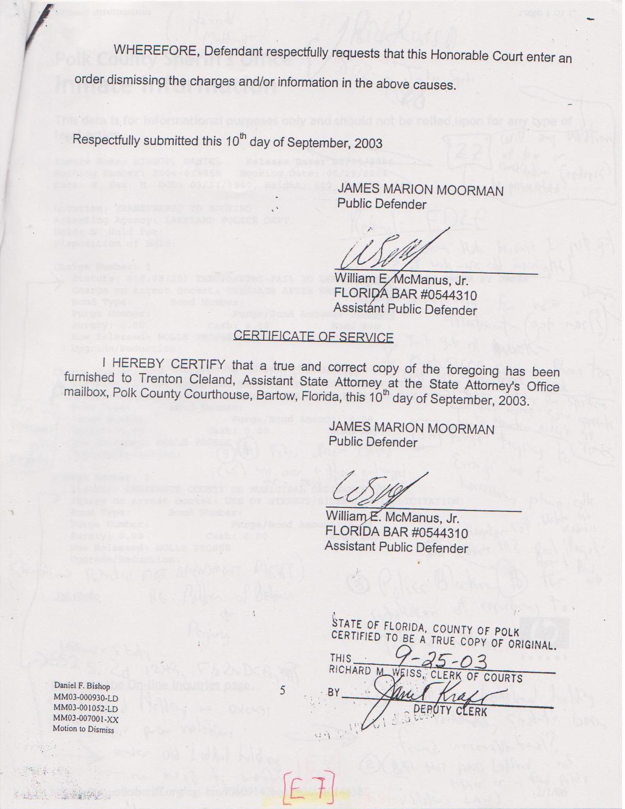

Note: Even after repeated warning here on 09-25-2003 (above), the Lakeland Police Department continued its illegal pattern of harassment against this gentleman (see below: Booking Date of 06-28-2004) -and probably many others. --Gordon Wayne Watts

