Notice, first, the way my Chapter 119 'Public Records' request to the Lakeland Police Department for some records was answered:
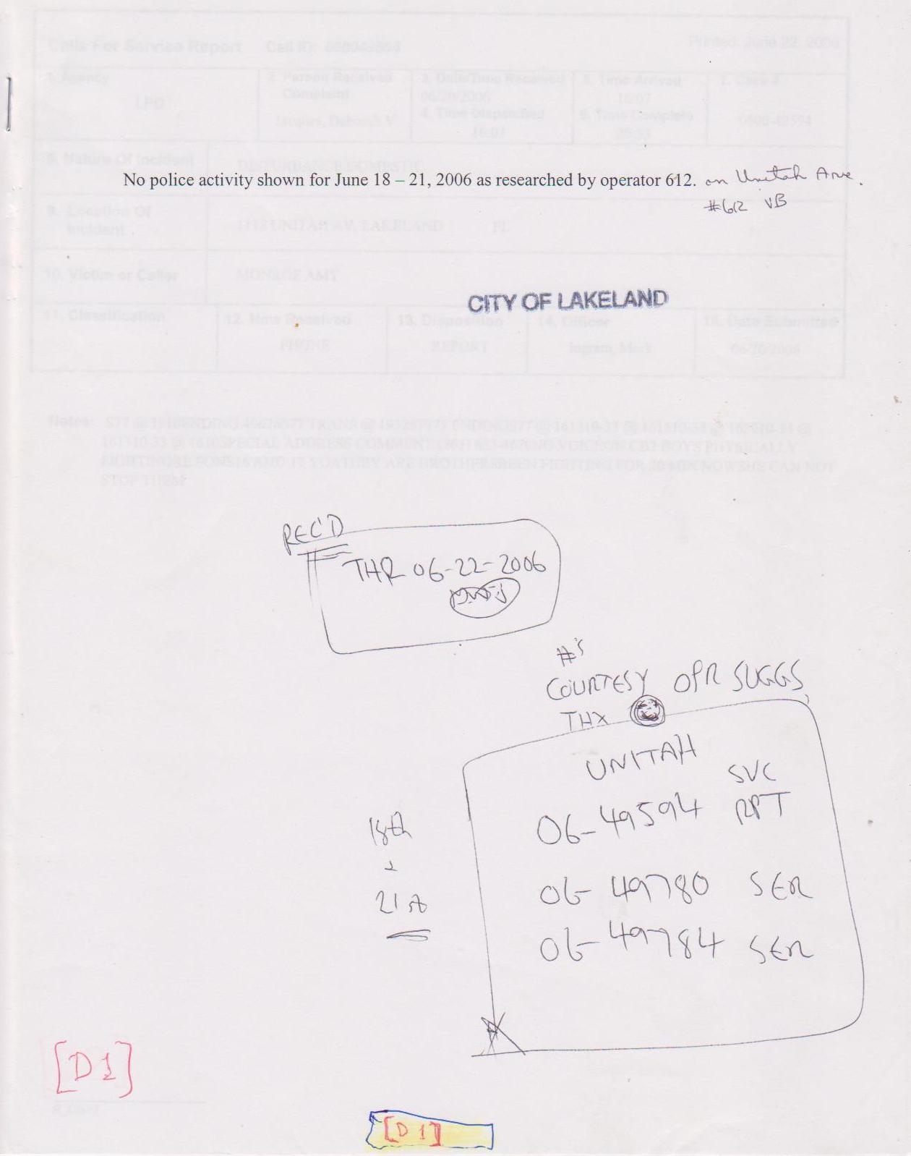
That's right: They said there were no records available – but, was that really true? - Observe:

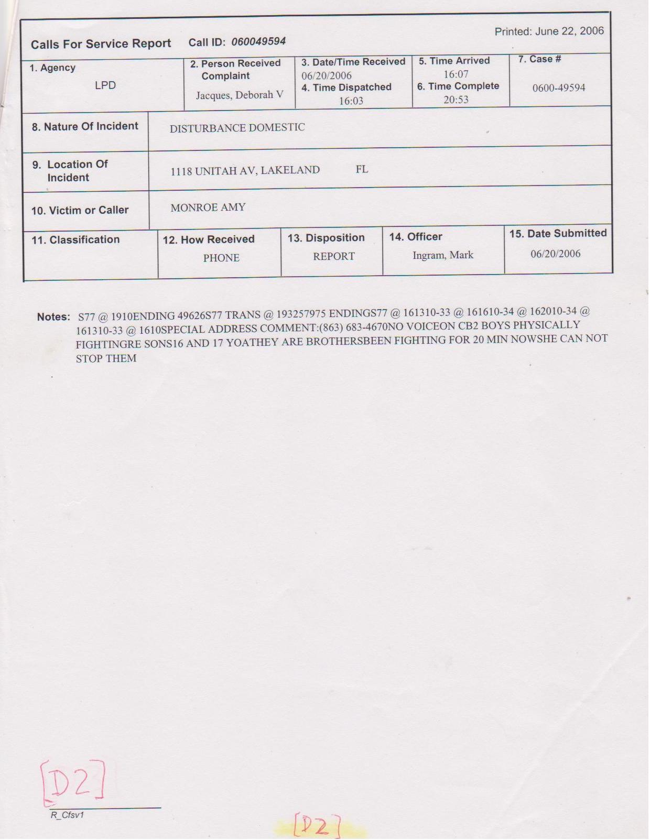

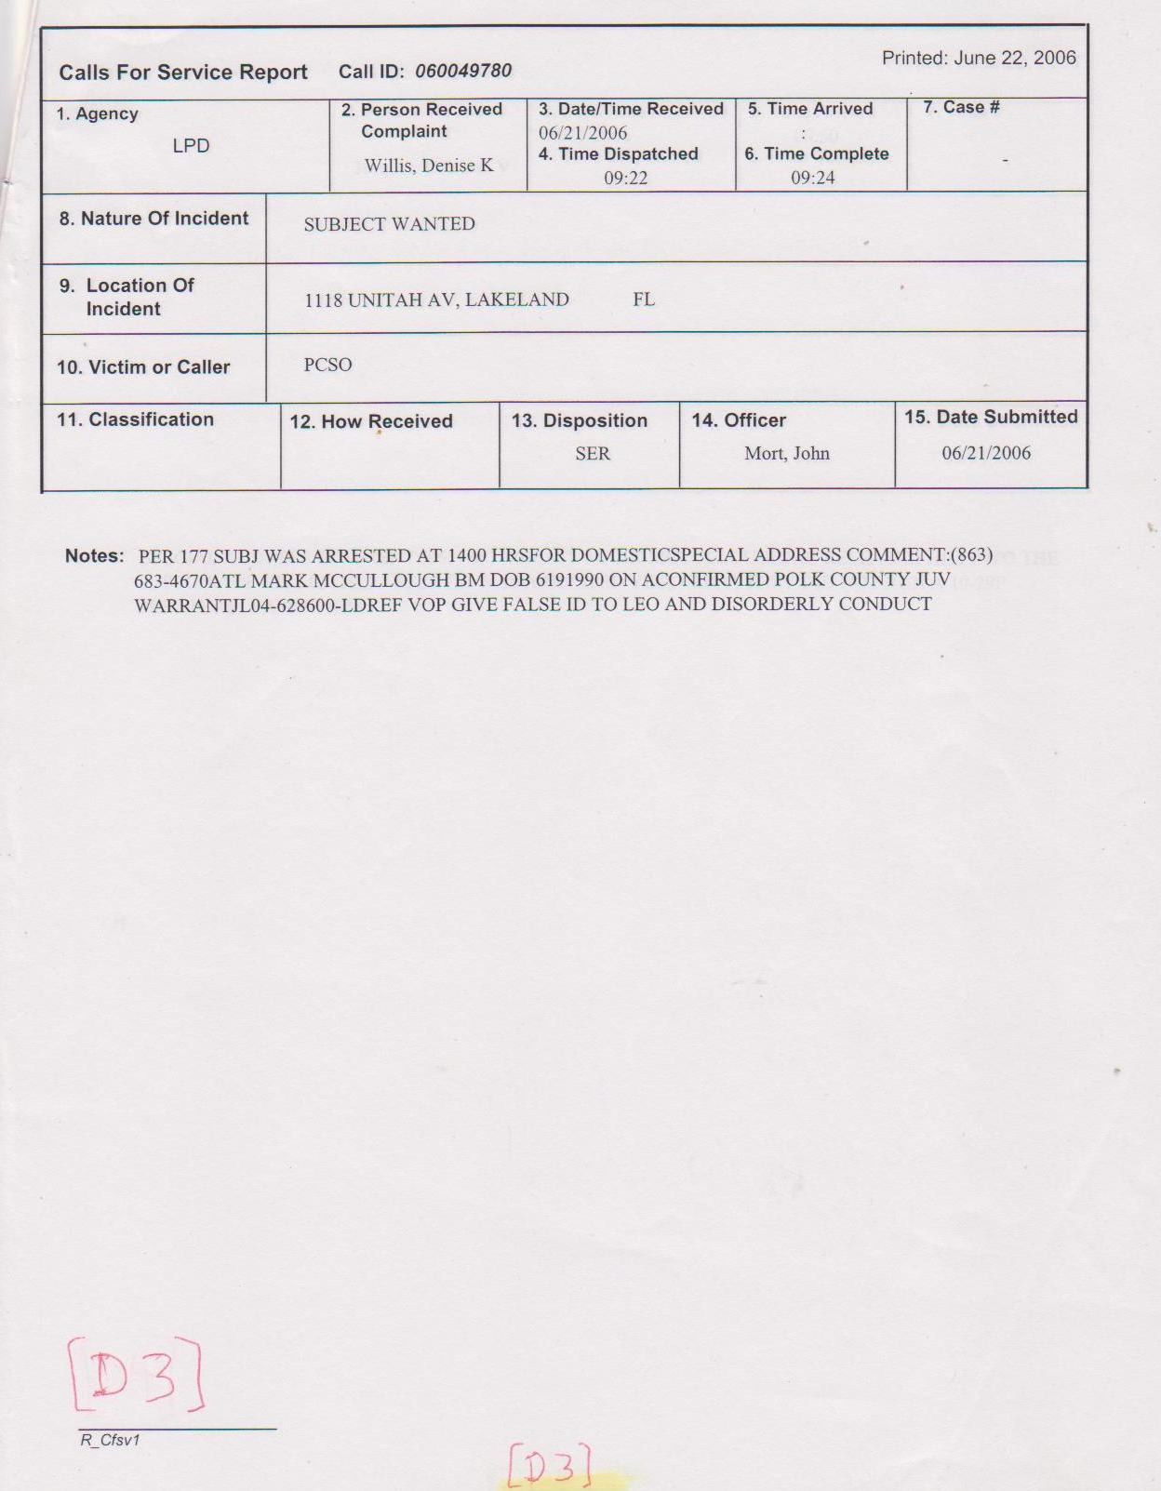
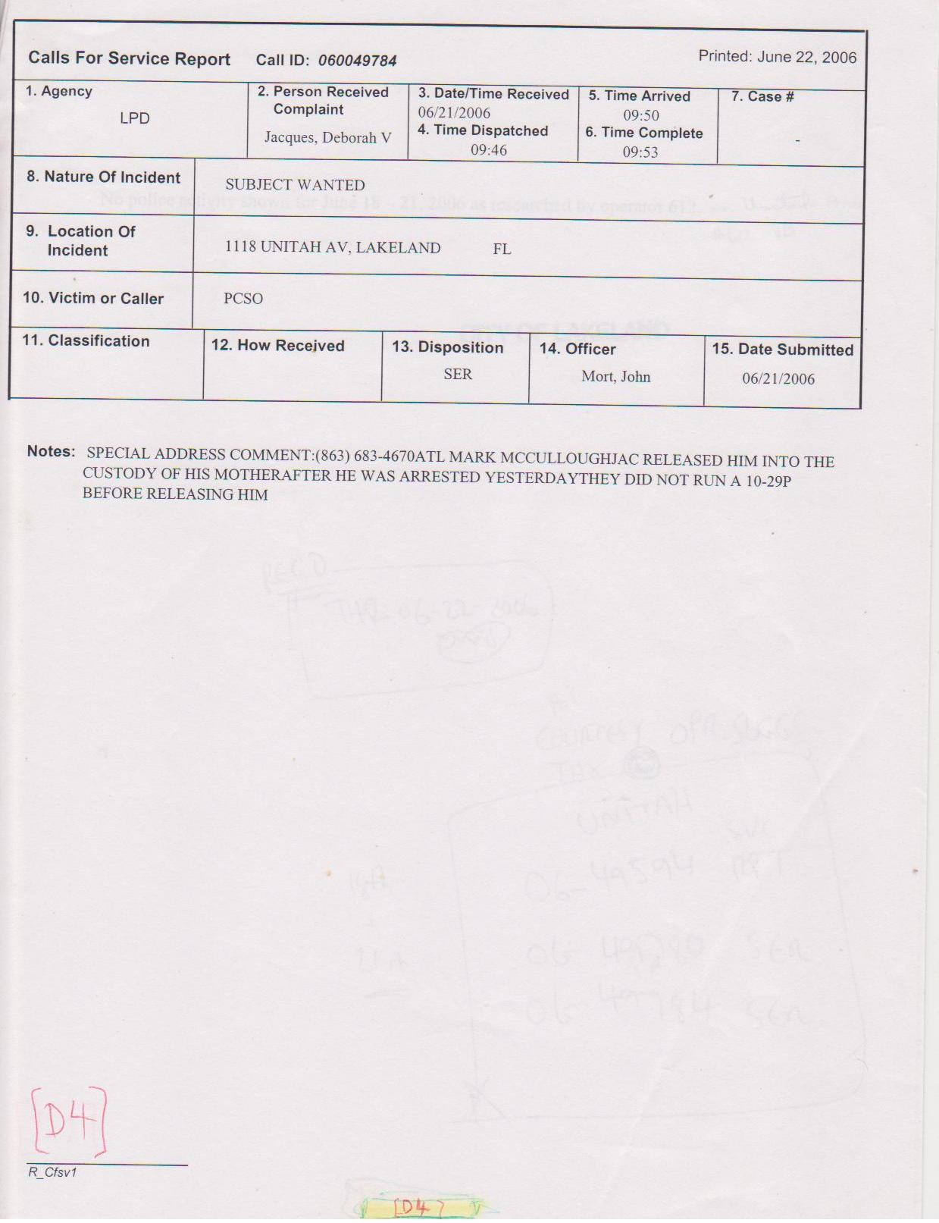
Comment: Obviously they contradict themselves -this was not the 1st time & probably won't be the last. --Gordon Wayne Watts, LAKELAND, Florida www.GordonWayneWatts.com ~ www.GordonWatts.com

