[Fair Use cached copy: like Google cache, but by The Register: GordonWatts.com / GordonWayneWatts.com Editor-in-chief, Gordon Wayne Watts]
[source: https://www.GoodCall.com/news/donald-trumps-hail-mary-higher-education-might-fail-09007 Snapshot as it appeared on Sat. 22 Oct. 2016.]
Why Donald Trump’s Hail Mary on Higher Education Might Fail

ELECTION 2016 – POSTED BY DEREK JOHNSON ON OCTOBER 19, 2016 AT 11:51 AM

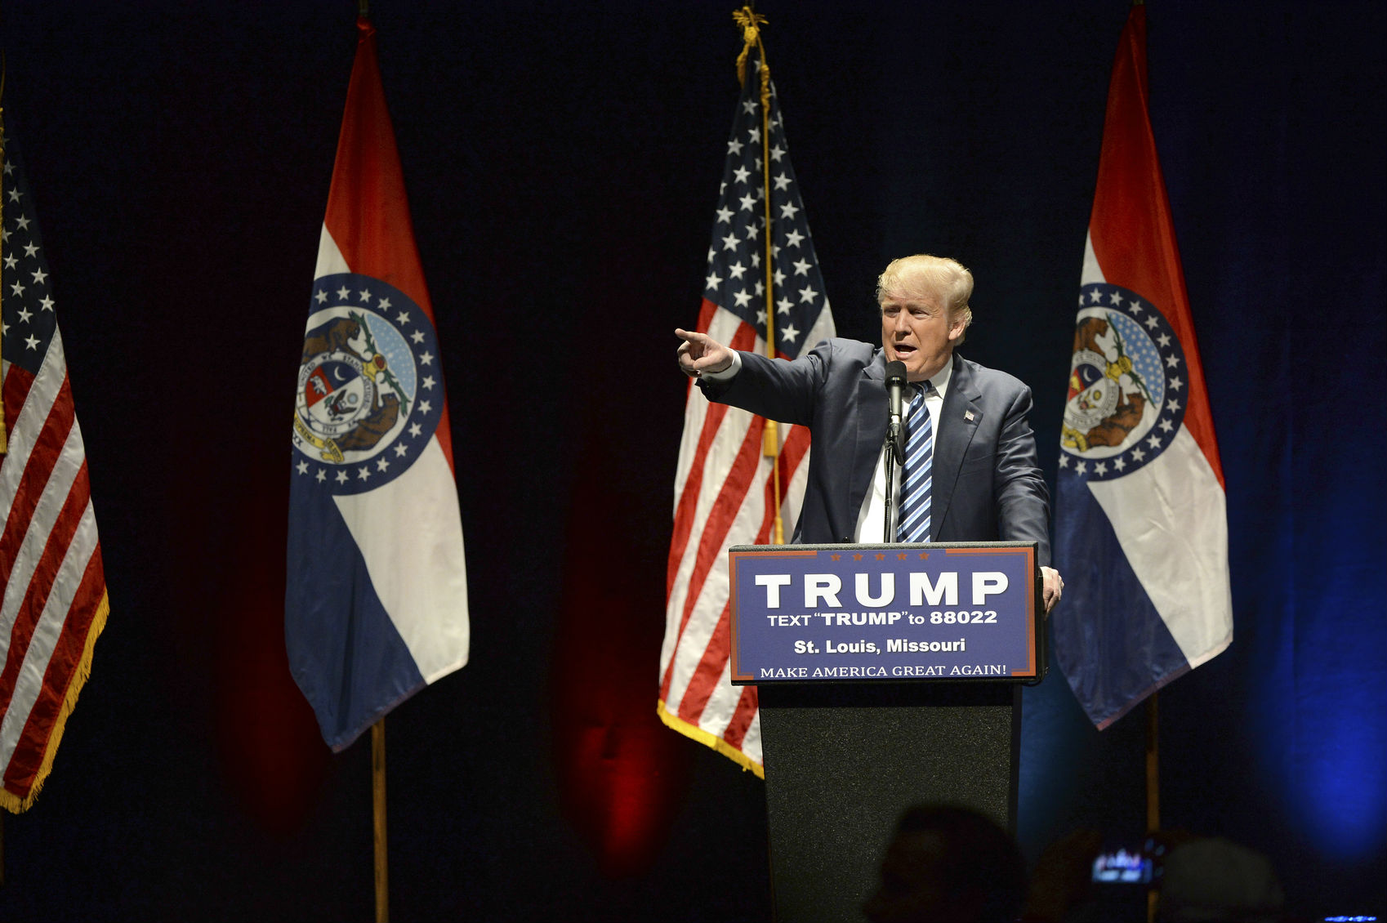
To our readers: Today, GoodCall looks at the leading 2016 presidential candidates and their latest education proposals. We begin with Republican Donald Trump and his recently announced higher-education plan. Additional note: We’ve updated this article with information from last night’s debate.

Something odd happened last week during a Republican presidential rally in Columbus, OH: Donald Trump discussed his plans for higher education.

For a year and a half, journalists and policy experts have searched in vain for evidence of what a Trump administration might do -= or even think – about issues such as ballooning student debt, for-profit universities, abysmal college dropout rates and sexual assault on campus.

Last Wednesday, the Republican presidential candidate gave his most substantive comments yet on higher education, outlining bold proposals such as universal income-driven repayment for all college students and reiterating a threat to tax the endowments of colleges that don’t do enough to reduce tuition and curb administrative bloat. At times, he came off sounding strikingly like Democratic opponent Hillary Clinton and her primary challenger Bernie Sanders, casting high student debt totals as morally wrong and fraught with uncertain returns.

“The biggest crisis is you graduate and do well from great colleges … then no jobs. No good jobs,” Trump said. “Students should not be asked to pay more on their loans than they can afford, and the debt should not be an albatross around their necks for the rest of the lives.”

Perhaps the most noteworthy comment was his proposal to structure federal student aid repayment to a purely income-driven system, with no borrowers paying more than 12.5 percent of their monthly income for a period of 15 years. After that, Trump hinted that those who stayed current on payments would have the rest of their public loans forgiven.

“Under my student loan program we would cap repayment for an affordable portion of a borrower’s income, 12.5 percent, we would cap it. That gives you a lot to play with and a lot to do. And if borrowers work hard and make their payments for 15 years, we’ll let them get on with their lives,” he said.

ALL ABOARD THE INCOME-BASED REPAYMENT BANDWAGON

Enrollment in income-driven repayment programs has expanded greatly under the Obama administration. However, most versions offer less generous terms (between 10 to 20 percent of monthly income over 10-25 years) and are targeted at lower income students. American Enterprise Institute’s Jason Delisle took to Twitter to point out that Trump’s proposal would dramatically increase loan forgiveness for upper-income students while doing “nothing” for low-income students.
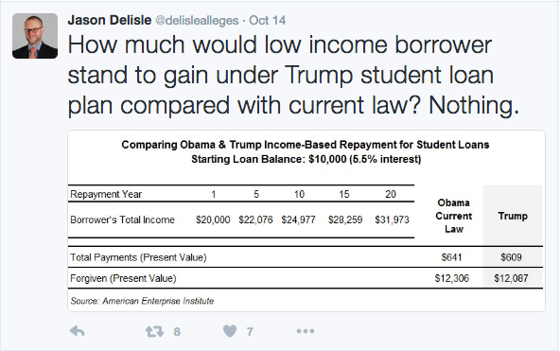

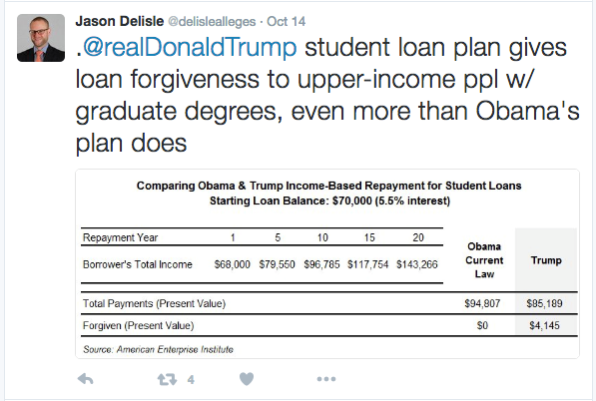
It’s not clear how these comments mesh with the Trump campaign’s previous stances on a range of higher education issues, mainly a widely cited interview in May with education adviser Sam Clovis. Clovis did not mention Trump’s student loan plan or income-driven repayment, nor did he discuss taxing university endowments or reducing administrative bloat as a means of reducing the cost of college. Alternatively, Trump did not comment on or reinforce any of the policies Clovis propounded, such as denying access to federal student loans for certain liberal arts majors or re-privatizing federal student lending.

TRUMP EDUCATION PROPOSALS MAKE A PLAY FOR YOUNG VOTERS

Trump’s seemingly out of the blue comments may have been tailored to his audience, both geographically and demographically. In addition to being a crucial swing state in the 2016 election, Ohio students have been among the hardest hit by rising college costs and mounting student debt totals. According to the Institute for College Access and Success, Ohio has the 12th worst student debt situation in the nation, with the average student owing $29,353 after leaving their four-year university. That debt is fairly widespread as well, with 67 percent of students holding debt (11th highest in the nation).

Trump’s campaign also may be targeting a weak point in Clinton’s voting coalition. As young voters who prioritize student debt issues are among the demographic groups least loyal to Clinton. Her campaign has spent much of the Democratic primary and aftermath trying to lure young voters back into the fold through bold higher education proposals, first by rolling out a debt-free college plan, then by adopting large elements of Bernie Sanders’ platform. For a Trump campaign that has more or less maximized its support from traditional Republican voting blocs, wooing young voters with an aggressive and generous student debt policy makes a lot of sense.

The Clinton campaign is taking this latest move seriously, releasing a statement Friday challenging Trump’s lack of a record on higher education and accusing his education proposals as being “empty promises.”

“More than a year after Secretary Clinton released her plan to take on college costs and student debt, we are still waiting for Donald Trump to lay out a detailed plan for addressing these issues,” the statement said. “The promises he has made so far are as empty as the promises he made to students at Trump University. There is only one candidate in this race with a real plan to make college debt-free and provide relief for millions of borrowers, and it is not Donald Trump.”

TOO LITTLE AND LIKELY TOO LATE

The reason Trump’s student loan gambit has very little chance of working is twofold. First, he has flat-out ignored higher education issues for the entire campaign. That was fine during the primary, as higher education has never been a very important issue with Republican voters. But after locking up the nomination in May, Trump waited until September to even mention the topic and mid-October to roll out any plans on student debt. Along the way he earned bad headlines in higher education media and cemented the idea in the minds of many voters that he didn’t care enough about higher education to develop a platform. Even during the final debate last night, his only mention of education was a vague promise: “… She can say all she wants about college tuition,” he said after Clinton outlined her position on education. “And I’m a big proponent. We’re going to do a lot of things for college tuition.”

Second, Trump holds views and has made comments about immigration, women, banning Muslims and political correctness that are electoral kryptonite with young voters most likely to be swayed by his new stance on student loans. If Clinton is disliked and distrusted by young America, Trump is downright repellent. A USA Today/Rock the Vote poll conducted in August found young voters were fleeing Trump at “unprecedented” and “historic” rates, with just 20 percent of voters under 35 saying they support the Republican nominee.

To put those numbers in perspective, the previous historic low for youth support was Richard Nixon, who pulled in 32 percent of similar voters in 1992 and as recently as 2000 the group was split evenly between Al Gore and George W. Bush. Even if young Americans like what they hear from Trump on student debt, it seems unlikely that it will cancel out the many other reasons they dislike him.

In an alternate timeline where Trump spent the past year laser-focused on courting young Democratic-leaning voters distraught at the impending loss of Bernie Sanders and still deeply distrustful of Clinton, a moonshot student loan proposal like this might have moved the needle. In this reality, he spent much of the spring and summer feuding with the Gold Star parents of a dead American soldier, calling an American-born judge “biased” because his parents were of Mexican descent and making a series of comments about women that have sent his poll numbers into a downward spiral.

In this timeline, putting forth an uber-generous student debt plan less than a month before election day that experts across the spectrum immediately decried the education proposals as poorly thought-out and unworkable only reinforces the idea that Trump has not given the problem much thought and strongly suggests it is nothing more than a last-minute Hail Mary from a desperate campaign.

Later today: A look at the role Hillary Clinton’s early childhood education proposals are playing in the 2016 election.
 | DEREK JOHNSON  Derek Johnson is a writer, journalist and editor based out of Virginia. He received a Master’s degree in Public Policy at George Mason University and a bachelor’s degree in Communication from Hofstra University.

