LEGAL ANALYSIS: [[**]] FLORIDA'S proposed Medical Marijuana “Amendment 2” violates Federal Law, contains lies that are misleading -and could even get you arrested, charged, & prosecuted under Federal charges: PROOF:
By GORDON WAYNE WATTS (Special Report – Breaking), THE REGISTER, Published: Saturday, August 30, 2014 (Updated: Sat. 09-13-2014)
[[**]] * Watts, who is not a lawyer, nearly won in court on behalf of Terri Schiavo, doing better than all other pro-life litigants, combined:
[1] In Re: GORDON WAYNE WATTS (as next friend of THERESA MARIE 'TERRI' SCHIAVO), No. SC03-2420 (Fla. Feb.23, 2003), denied 4-3 on rehearing (Watts got 42.7% of his panel) http://www.floridasupremecourt.org/clerk/dispositions/2005/2/03-2420reh.pdf
[2] In Re: JEB BUSH, GOVERNOR OF FLORIDA, ET AL. v. MICHAEL SCHIAVO, GUARDIAN: THERESA SCHIAVO, No. SC04-925 (Fla. Oct.21, 2004), denied 7-0 on rehearing. (Bush got 0.0% of his panel before the same court) http://www.floridasupremecourt.org/clerk/dispositions/2004/10/04-925reh.pdf
[3] Schiavo ex rel. Schindler v. Schiavo ex rel. Schiavo, 403 F.3d 1223, 2005 WL 648897 (11th Cir. Mar.23, 2005), denied 2-1 on appeal. (Terri Schiavo's own blood family only got 33.3% of their panel on the Federal Appeals level)
[4] Sample brief: Mirror 1 – Mirror 2
August 30, 2014 at 7:22pm [Related Facebook social network link]
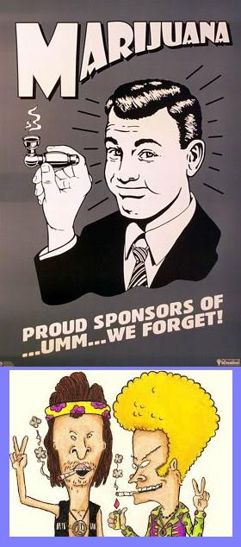 | There is some misunderstanding here, among Florida voters: Even though I (editor-in-chief, Gordon W. Watts) support removing marijuana from 'Schedule 1' status (and thus permitting research), “weed” (marijuana) is not only illegal, it will remain illegal under Federal Law -and could get you arrested, despite the lies that are told in the Ballot Language of Am.2 - PROOF: *Profile pic caption: “Marijuana: Proud sponsors of..um.. we forgot!” --Bevis & Butthead (Various pics combined used under Federal Fair Use guidelines: for review or criticism for purposes of illustration or comment, and parody of some of the content of the work parodied; summary of an address or article, with brief quotations, in a news report)
[[""Since 1970, the federal government has refused to recognize the medical value of marijuana. Marijuana is still a schedule one substance in their eyes, and so they have the “authority” to enforce their laws, even in medical marijuana states – states who voted for and who want medical marijuana.
What does this mean? Let’s say you live in a medical marijuana state. You have obtained your medical marijuana card through the correct, legal, and legitimate channels and you’re in total compliance with your state’s laws regarding medical marijuana. If you get arrested and are facing federal charges for marijuana cultivation, for example, you are not allowed to use your state’s medical marijuana laws as a defense. It doesn’t matter if it’s legal in Colorado, it’s illegal under federal law.
On July 17, Representative Farr (D-CA), and 18 co-sponsors, introduced HR 6134, The Truth in Trials Act, which would fix this problem and allow people tried in federal court for marijuana related offenses to call upon evidence that they were in compliance with their state’s medical marijuana laws. It doesn’t matter if it’s illegal under federal law, you’re protected under Colorado law.
“Truth in Trials Act Protects State Medical Marijuana from Federal Prosecution,” July 19, 2012, by Drew Stromberg""]] http://ssdp.org/news/blog/truth-in-trials-act-protects-state-medical-marijuana-from-federal-prosecution/ (Quotes used under Federal Fair Use guidelines: for review or criticism for purposes of illustration or comment, and parody of some of the content of the work parodied; summary of an address or article, with brief quotations, in a news report) >>This comes from a "pro-weed" website, and even this website here admits I'm correct: Methinks the supporters on Amendment Two are too stoned to see this.^^**
GORDON RESPONDS: The Am.2 summary states the following: “Applies only to Florida law. Does not authorize violations of federal law or any non-medical use, possession or production of marijuana.” When read together with the entire ballot summary and title, these statements imply that qualifying patients may lawfully use and possess marijuana if the amendment passes. However, this is absolutely false. Whether or not this amendment passes, the medical use of marijuana will remain a prosecutable federal crime - that could get you arrested, charged, and prosecuted. Period.
PROOF: Read the ACTUAL Ballot Language here: http://www.floridasupremecourt.org/decisions/2014/sc13-2006.pdf Thanks to a Patriot friend, I am reminded that the FEDERAL LAW has jurisdiction and TRUMPS anything State - meaning that even if Florida's “Medical Marijuana” Amendment 2 passes, Feds will still legally be able to arrest, charge, and prosecute you for weed possession - period – PROOF:
- * Article VI, Paragraph 2 of The U.S. Constitution is commonly referred to as the Supremacy Clause. It establishes that the federal constitution, and federal law generally, take precedence over state laws, and even state constitutions. http://www.law.cornell.edu/wex/supremacy_clause (Fair Use Quote)
- The U.S. Supreme Court agrees: “In a 6-3 opinion delivered by Justice John Paul Stevens, the Court held that the commerce clause gave Congress authority to prohibit the local cultivation and use of marijuana, despite state law to the contrary.” GONZALES V. RAICH (03-1454) 545 U.S. 1 (2005), 352 F.3d 1222, vacated and remanded. http://www.oyez.org/cases/2000-2009/2004/2004_03_1454 Cf: http://www.law.cornell.edu/supct/html/03-1454.ZO.html
- Actually, that just happened to these unlucky blokes in California - weed laws did not protect them from harsh penalties: Look up “Marin Alliance For Medical Marijuana v. Holder N.D.Cal., Nov. 28, 2011” https://www.casetext.com/case/marin-alliance-for-med-marijuana-v-holder
- Right or wrong (on moral grounds), U.S. Atty. General, Eric Holder, and crew, CAN and DO still prosecute: http://blogs.justice.gov/main/archives/192
- “The 2005 U.S. Supreme Court case Gonzales vs. Raich established the federal government has the right to use the Commerce Clause of the Constitution to regulate homegrown marijuana, even when it’s for approved medicinal use. DEA officials destroyed Oakland, Calif., resident Angel Raich’s homegrown marijuana plants in 2002, despite the fact Raich’s possession was legal under California’s Proposition 215 medical marijuana law, which was passed in 1996. [line break] Raich sued the federal government and lost, but California’s law was not affected. The ruling showed that the federal government cannot force states to criminalize something (marijuana, in this case), but can enforce its own laws.” PolitiFact: “[Fla. Atty. General] Pam Bondi says medical marijuana is illegal under federal law, with or without amendment”: Rated 'TRUE' - http://www.politifact.com/florida/statements/2013/dec/17/pam-bondi/pam-bondi-says-medical-marijuana-illegal-under-fed/
[[“Marin Alliance for Med. Marijuana v. Holder
866 F.Supp.2d 1142 (E.D. Cal. 2011)

ORDER DENYING PLAINTIFFS' MOTION FOR TEMPORARY RESTRAINING ORDER
SAUNDRA BROWN ARMSTRONG, District Judge.

Three medical marijuana dispensaries, one of their landlords and a medical marijuana patient bring the instant action to challenge recent threats by the United States Department of Justice (“DOJ”) to take legal action against landlords of medical marijuana dispensaries in the Northern District of California. The parties are now before the Court on Plaintiffs' motion for a temporary restraining order (“TRO”), which seeks an immediate injunction to prevent the federal government from arresting, prosecuting, or otherwise seeking sanctions or forfeitures against medical marijuana growers and providers who operate under the auspices of California's Compassionate Use Act of 1996. As will be set forth below, binding Supreme Court and Ninth Circuit precedent foreclose Plaintiffs' claims, and therefore, the Court DENIES Plaintiffs' motion for a TRO.1
1.
The Court adjudicates the instant motion without oral argument. See Fed.R.Civ.P. 78(b); Civ. L.R. 7–1(b).”]]

Right or wrong (on moral grounds), U.S. Atty. General, Eric Holder, and crew, CAN and DO still prosecute: http://blogs.justice.gov/main/archives/192

[[“MEMORANDUM FOR SELECTED UNITED STATES ATTORNEYS
FROM: David W. Ogden, Deputy Attorney General
SUBJECT: Investigations and Prosecutions in States Authorizing the Medical Use of Marijuana

This memorandum provides clarification and guidance to federal prosecutors in States that have enacted laws authorizing the medical use of marijuana...Of course, no State can authorize violations of federal law, and the list of factors above is not intended to describe exhaustively when a federal prosecution may be warranted...Your offices should continue to review marijuana cases for prosecution on a case-by-case basis, consistent with the guidance on resource allocation and federal priorities set forth herein, the consideration of requests for federal assistance from state and local law enforcement authorities, and the Principles of Federal Prosecution.

cc: All United States Attorneys”]]

Besides being an illegal (unconstitutional) amendment, the ballot language is misleading (dishonest). Lastly, weed may be helpful, but remembering how thalidomide was “rushed” into the market, with deadly results, we need more research: Weed advocates should seek removal of 'Schedule 1' status, and not 'rush' things: Impatience can be deadly.
OK, now that we've gotten all serious & realised that I'm correct in my claims that this amendment contains deceptive lies –that could get you arrested (click the links to find out), here's a little humour:
Florida's Amendment 2
A well stoned militia, being necessary to the security of a police state, the right of the people to keep and bear weed, shall not be infringed.
NEW: Here's some additional weed research – some of it “anti-weed,” but also some of it “pro-weed,” which should show you that I'm open-minded –and not “prejudiced” against my weed-smoking, pot-head friends:
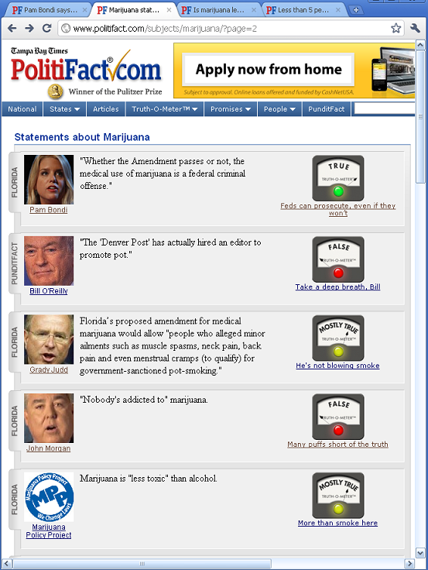
Source: http://www.politifact.com/subjects/marijuana/?page=2
Note here that top item says: “Pam Bondi says medical marijuana is illegal under federal law, with or without amendment...Even with the caveats implied by the U.S. government’s recent guidance, Bondi’s office declared "whether the Amendment passes or not, the medical use of marijuana is a federal criminal offense." Whether you’re a supporter of states’ rights or not, she’s correct. [line break] We rate this statement True”
This confirms –and vindicates – my initial legal analyses; however, the bottom item (showing Marijuana is “less toxic” than alcohol) shows, clearly, that both PolitiFact (who published this) and myself (who is citing it here) are not narrow-minded “haters” of weed. While weed, indeed, is not that healthy, I am an unbiased and honest “Ron Paul” Republican who admits that it is less harmful than alcohol.

Here are additional citations that show I am not a “hater” of Liberal or Democratic causes (Civil Rights for African Americans) or prominent Democratic Leaders (Pres. Barack Obama) →
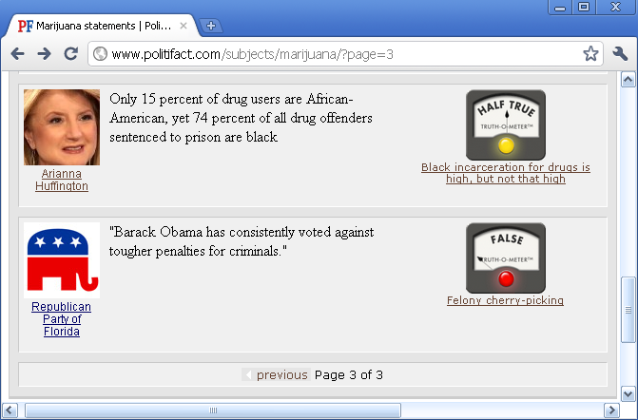
Source: http://www.politifact.com/subjects/marijuana/?page=3

( LEGAL DISCLAIMER: Selected screen-shots from the PolitiFact 'fact checker' website, cited & used under Federal Fair Use guidelines: for review or criticism for purposes of illustration or comment, and summary of an address or article, with brief quotations, in a news report – THIS news report, to be exact. )

Lastly, see the last page following: Here are still more citations that show I am not a “hater” of Liberal or Democratic causes: I cite some items that support traditionally liberal, Democratic, and/or pro-weed claims...

(see next page) →

Clearly, I'm not a 'hater':
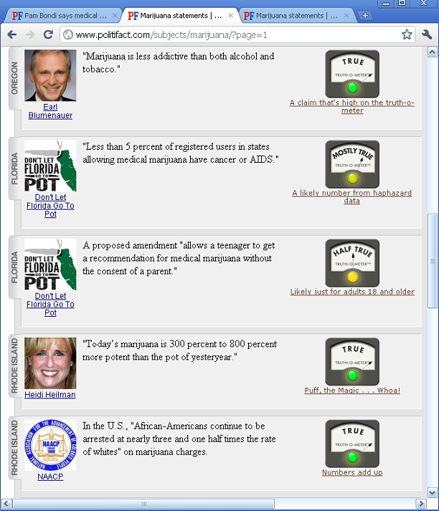
Source: http://www.politifact.com/subjects/marijuana/?page=1

Navigation:
* http://GordonWatts.com
* http://GordonWayneWatts.com
* http://Twitter.com/Gordon_W_Watts
* http://GordonWayneWatts.BlogSpot.com
* http://YouTube.com/GordonWayneWatts
* http://Facebook.com/GordonWayneWatts
* http://Gordon_Watts.Tripod.com/consumer.html

